WAJP for creation and casting of variables.

Code :
public class Practical1
{
public static void main(String[] args)
{
System.out.println("Name : Alisha Khan");
System.out.println("Objective : Creating and casting of variables.");

// Variable Creation
int intVar = 100;
double doubleVar = 50.5;
float floatVar = 30.0f;
char charVar = 'A';
String stringVar = "Hello, Java!";

// Print original values
System.out.println("\nOriginal values:");
System.out.println("intVar : " + intVar);
System.out.println("doubleVar : " + doubleVar);
System.out.println("floatVar : " + floatVar);
System.out.println("charVar : " + charVar);
System.out.println("stringVar : " + stringVar);

//Widening Casting
double WideDouble = intVar;
System.out.println("\nWidened int variable to double : " + WideDouble);

//Narrowing Casting
int narrowInt = (int) doubleVar;
System.out.println("Narrowed double variable to int : " + narrowInt);

//casting char to int
int asciiValue = (int) charVar;
System.out.println("ASCII value of char variable : " + asciiValue);

//cast the integer variable to a string
String str2 = Integer.toString(intVar);
System.out.println("Casted Integer variable to a string : " +str2);

}
}

Output :

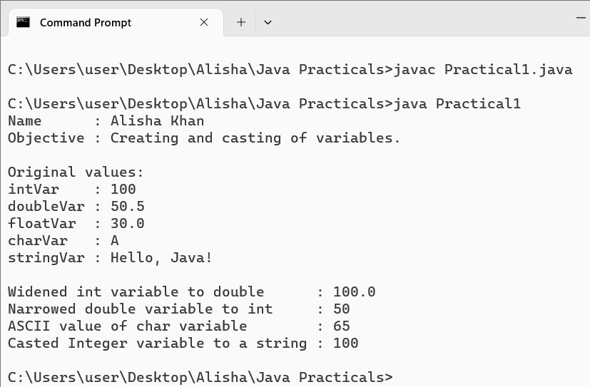

WAJP for demonstrate the various operators.
Code :
import java.util.*;
public class Practical2
{
public static void main(String[] args)
{
System.out.println("Name : Alisha Khan");
System.out.println("Objective : Demonstrate the various operators.");

Scanner sc = new Scanner(System.in); //System.in is a standard input stream
System.out.print("\nEnter first number : ");
int a = sc.nextInt();

System.out.print("Enter Second Number : ");
int b = sc.nextInt();

System.out.println("\nArithmetic operators :");
System.out.println("Addition : A + B = " + (a + b));
System.out.println("Subtraction : A - B = " + (a - b));
System.out.println("Multiplication : A * B = " + (a * b));
System.out.println("Division : A / B = " + (a / b));
System.out.println("Modulus : A % B = " + (a % b));

System.out.println("\nRelational Operators :");
System.out.println("Equal to : A == B : " + (a==b));
System.out.println("Not equal to : A != B : " + (a!=b));
System.out.println("Greater than : A > B : " + (a>b));
System.out.println("Less than : A < B : " + (a<b));
System.out.println("Greater than equal to : A >= B : " + (a>=b));
System.out.println("Less than equal to : A <= B : " + (a<=b));

System.out.println("\nAssignment Operators : ");
System.out.print("Enter Value for assignment operator : ");
float c = sc.nextFloat();

System.out.println("\nEquivalent to c + 5 : ");
System.out.println("c += 5 : " + (c+=5));
System.out.println("c -= 5 : " + (c-=5));
System.out.println("c = 5 : " + (c=5));
System.out.println("c /= 5 : " + (c/=5));
System.out.println("c %= 5 : " + (c%=5));
System.out.println("c *= 5 = " + (c*=5));

boolean x = true;
boolean y = false;
System.out.println("\nLogical Operators:");
System.out.println("Logical AND : x && y: " + (x && y));
System.out.println("Logical OR : x || y: " + (x || y));
System.out.println("Logical NOT : !x: " + (!x));

System.out.println("\nBitwise Operators:");
System.out.println("Bitwise AND : A & B = " + (a & b));
System.out.println("Bitwise OR : A | B = " + (a | b));
System.out.println("Bitwise XOR : A ^ B = " + (a ^ b));
System.out.println("Bitwise Complement : ~A = " + (~a));
System.out.println("Left shift : A << 2 = " + (a << 2));
System.out.println("Right shift : A >> 2 = " + (a >> 2));
System.out.println("Unsigned right shift: A >>> 2 = " + (a >>> 2));

int d = a;
System.out.println("\nUnary Operators:");
System.out.println("Value of D : D = " + d);
System.out.println("Pre-increment : ++D = " + (++d));
System.out.println("Post-increment : D++ = " + (d++));
System.out.println("Current value : D = " + d);
System.out.println("Pre-decrement : --D = " + (--d));
System.out.println("Post-decrement : D-- = " + (d--));
System.out.println("Current value : D = " + d);

System.out.println("\nTernary Operator:");
int max = (a > b) ? a : b;
System.out.println("Max value : " + max);
}
}

Output :

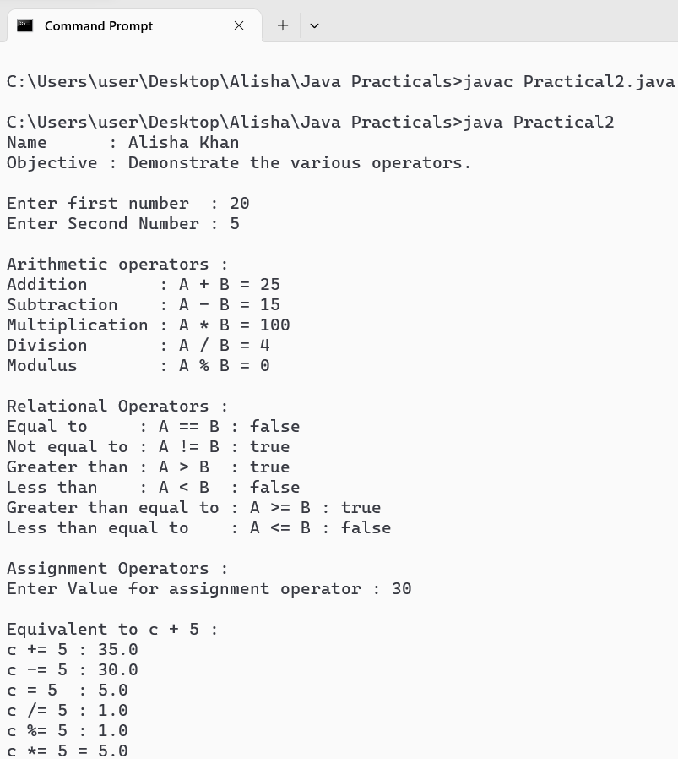

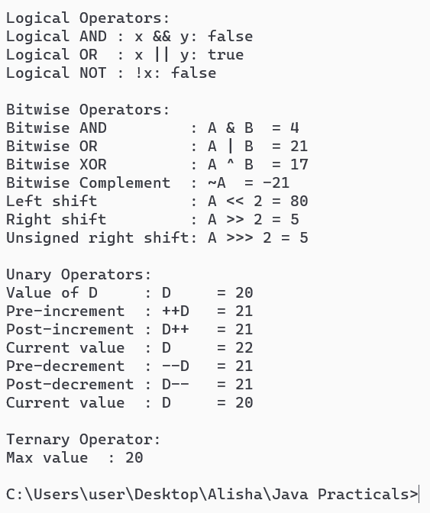

WAJP for printing the current data in different formats.

Code :
import java.time.LocalDate;
import java.time.LocalDateTime;
import java.time.format.DateTimeFormatter;

public class Practical3 {
public static void main(String[] args) {
System.out.println("Name : Alisha Khan");
System.out.println("Objective : Creating and casting of variables.\n");
// get the current date
LocalDate currentDate = LocalDate.now();

// print the current date in different formats
System.out.println("Current date: " + currentDate);

System.out.println("Current date (short format) : " +
currentDate.format(DateTimeFormatter.ofPattern("MM/dd/yyyy")));

System.out.println("Current date (medium format): " +
currentDate.format(DateTimeFormatter.ofPattern("MMM dd, yyyy")));

System.out.println("Current date (long format) : " +
currentDate.format(DateTimeFormatter.ofPattern("MMMM dd, yyyy")));

System.out.println("Current date (full format) : " +
currentDate.format(DateTimeFormatter.ofPattern("EEEE, MMMM dd, yyyy")));

// get the current date and time
LocalDateTime currentDateTime = LocalDateTime.now();

// print the current date and time in different formats
System.out.println("Current date and time : " + currentDateTime);

System.out.println("Current date and time (short format) : " +
currentDateTime.format(DateTimeFormatter.ofPattern("MM/dd/yyyy hh:mm a")));

System.out.println("Current date and time (medium format): " +
currentDateTime.format(DateTimeFormatter.ofPattern("MMM dd, yyyy hh:mm:ssa")));

System.out.println("Current date and time (long format) : " +
currentDateTime.format(DateTimeFormatter.ofPattern("MMMM dd, yyyy hh:mm:ssa")));

System.out.println("Current date and time (full format) : " +
currentDateTime.format(DateTimeFormatter.ofPattern("EEEE, MMMM dd, yyyyhh:mm:ss a")));
}
}

Output :

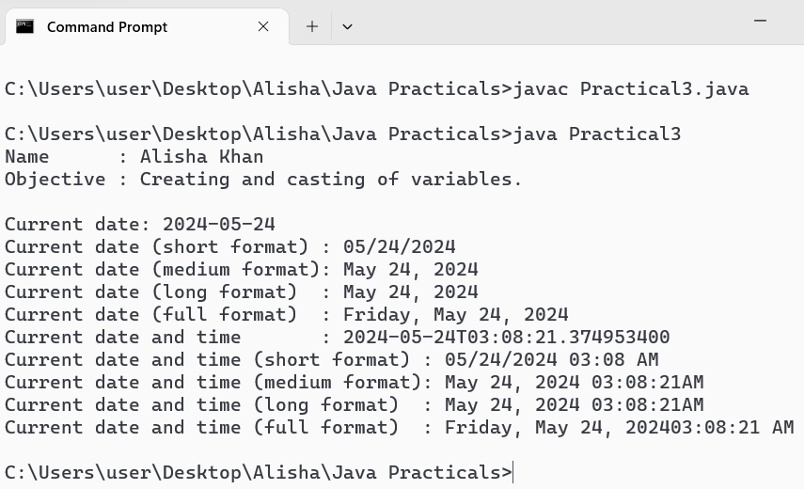

WAJP for inputting data from keyword through Scanner class.

Code :
import java.util.Scanner;
public class Practical4
{
public static void main(String[] args)
{
System.out.println("Name : Alisha Khan");
System.out.println("Objective : Inputing data from keyboard through Scanner class.");

//create a scanner object to read input from the keyboard
Scanner sc = new Scanner(System.in);

System.out.println("\nEnter the following data : ");
//input an integer
System.out.print("Enter an integer : ");
int a = sc.nextInt();

//input a double
System.out.print("Enter a double : ");
Double b = sc.nextDouble();

//input a String
System.out.print("Enter a String : ");
String str = sc.next();

//Display intered values
System.out.println("");
System.out.println("Entered Values :- ");
System.out.println("Integer Value : " +a);
System.out.println("Double Value : " +b);
System.out.println("String Value : " +str);

}
}

Output :

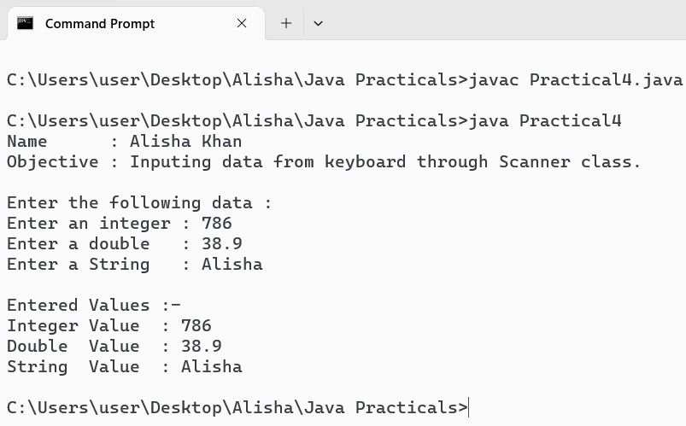

WAJP for inputting data from keyboard through BufferReader class.

Code :
import java.io.BufferedReader;
import java.io.InputStreamReader;
import java.io.IOException;

public class Practical5
{
public static void main(String[] args) throws IOException
{
System.out.println("Name : Alisha Khan");
System.out.println("Objective : Inputing data from keyboard through BufferedReader class.");

//Creating a BufferedReader object
BufferedReader reader = new BufferedReader(new InputStreamReader(System.in));

System.out.println("\nEnter a line of text : ");
String line = reader.readLine();
System.out.println("\nEnter an integer : ");
String number = reader.readLine();

System.out.println("\nDisplaying entered data : ");
System.out.println("Entered text : " + line);
System.out.println("Entered Number : " + number);
}
}
Output :

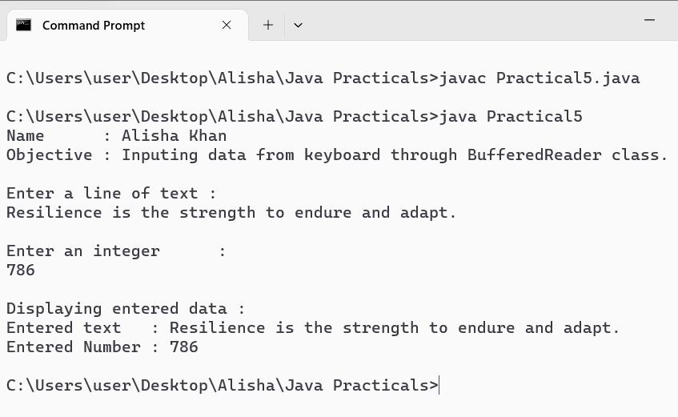

WAJP for inputting data from keyword through Console class.

Code :
import java.io.Console;
public class Practical6
{
public static void main(String[] args)
{
System.out.println("Name : Alisha Khan");
System.out.println("Objective : Inputing data from keyboard through console class.");

//Create a console object to read input from the keyboard
Console console = System.console();

if (console == null)
{
System.out.println("Console not available....Exiting!!");
System.exit(1);
}

//Reading a password
char[] password = console.readPassword("\nEnter your password : ");
System.out.println("Password Entered Successfully . ");
System.out.println("");

boolean showpwd = false;
String showpwdInput = console.readLine("Display the entered Password ? (YES / NO ) : ");

if(showpwdInput.equalsIgnoreCase("YES")) {
showpwd = true;
}
else {
System.out.println("Password Entered Successfully . ");
}
System.out.println("Entered Password : " + new String(password));

//input a string
System.out.println("");
String str = console.readLine("Enter a string : ");
System.out.println("Your entered string : " +str);
}
}

Output :

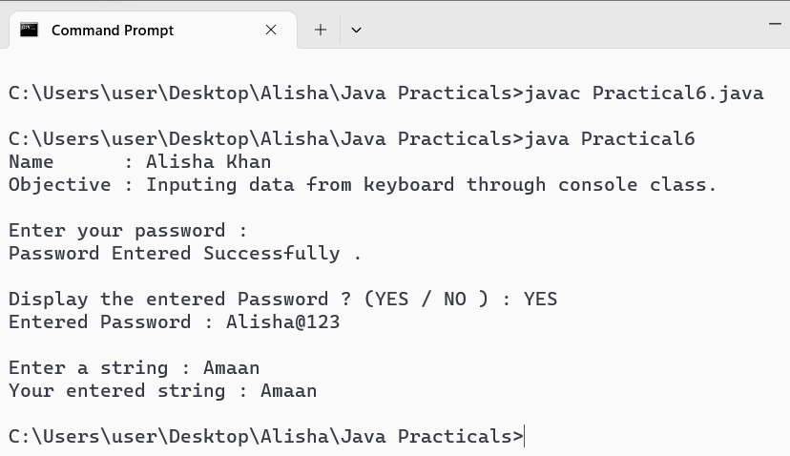

WAJP to demonstrate the use of for-each loop.
Code :
public class Practical7
{
public static void main(String[] args)
{
System.out.println("Name : Alisha Khan");
System.out.println("Objective : Demonstrate use of for each loop.");

//Declare and initialize an array of integers
int[] numbers = {10, 20, 30, 40, 50};
int sum = 0; //Variable to store the sum of elemments

//Display the elements of array
System.out.println();
System.out.println("Elements of the array : ");
for (int number : numbers) {
System.out.print(number + " ");
}
System.out.println();

//Calculate the sum of elemments using for-each loop
for (int number : numbers) {
sum += number ;
}
//Print the sum of elements
System.out.println("\nSum of elements in the array : " + sum);
}
}
Output :

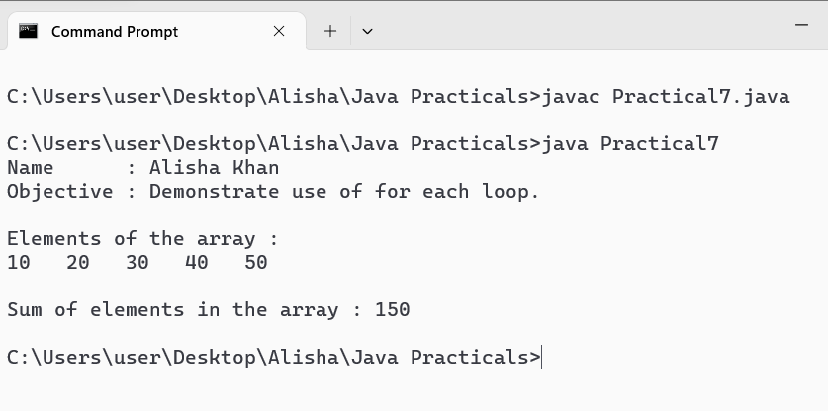

WAJP to demonstrate ragged arrays.
Code :
public class Practical8
{
public static void main(String[] args)
{
System.out.println("Name : Alisha Khan");
System.out.println("Objective : Demonstrate ragged arrays.");

//create a ragged array
int[][] raggedArray = { {1,2}, {3,4,5}, {6,7,8,9} };
System.out.println("\nRagged Array : \nint[][] raggedArray = { {1,2}, {3,4,5}, {6,7,8,9} }");

System.out.println("\nPrinting the content of ragged array : \n");
for (int i=0; i<raggedArray.length; i++)
{
for (int j=0; j<raggedArray[i].length; j++)
{
System.out.print(raggedArray[i][j]+" ");
}
System.out.println();
}
}
}

Output :

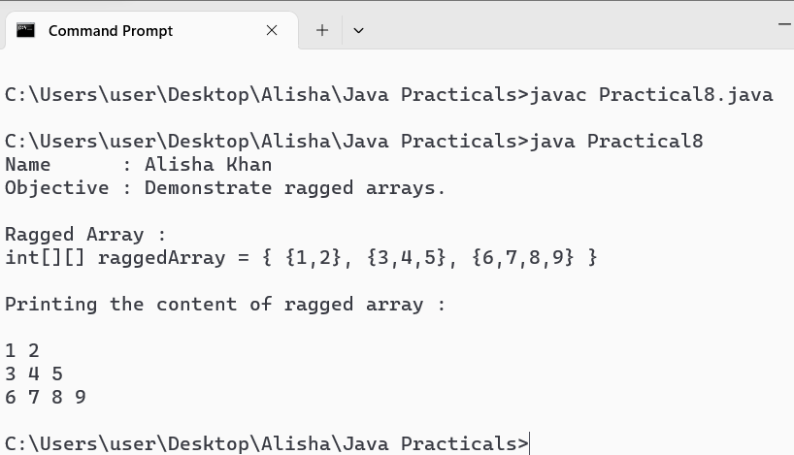

WAJP to demonstrate anonymous arrays.
Code :
public class Practical9
{
public static void main(String[] args)
{
System.out.println("Name : Alisha Khan");
System.out.println("Objective : Demonstrate Anonymous arrays.");

//create and print an Anonymous Array of integers
System.out.println("\nAnonymous Array of integers : ");
printArray(new int[] {1,2,3,4,5});

//create a print an Anonymous array of strings
System.out.println("Anonymous Array of strings : ");
printArray(new String[] {"Hello", "World", "!"});

//create and print an anonymous array of doubles
System.out.println("Anonymous array of doubles :");
printArray(new double[] {1.0, 2.0, 3.2, 4.5, 5.9});

}

public static void printArray(Object arr)
{
if(arr instanceof int[]) {
for (int element :(int[]) arr) {
System.out.print(element + " ");
}
}else if (arr instanceof double[]) {
for (double element :(double[]) arr) {
System.out.print(element+ " ");
}
}else {
for (Object element: (Object[]) arr) {
System.out.print(element+ " ");
}
}
System.out.println();
}
}

Output :
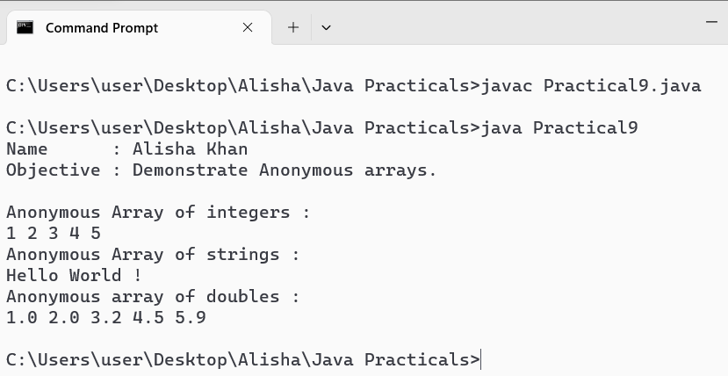

WAJP to demonstrate the method of array class.
Code :
import java.util.Arrays;
public class Practical10 {
public static void main(String[] args)
{
System.out.println("Name : Alisha Khan");
System.out.println("Objective : Demonstrate the method of array class.");

int[] arr = {23, 40, 11, 45, 10, 8, 112, 2 };

//print the contents of the array
System.out.println("\nOriginal array : ");
System.out.println(Arrays.toString(arr));

//sort the array in ascending order
Arrays.sort(arr);
System.out.println("\nSorted Array : ");
System.out.println(Arrays.toString(arr));

//Search for an element in the array using binary search
int index = Arrays.binarySearch(arr,40);
System.out.println("\nIndex of 40 in the sorted array : "+ index);

//fill the array with a value
Arrays.fill(arr,0);
System.out.println("\nArray after filling with 0 : ");
System.out.println(Arrays.toString(arr));
}
}
Output :

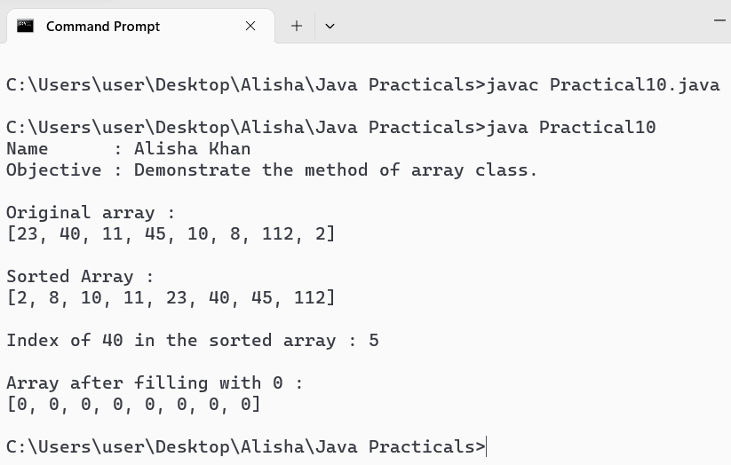

WAJP for application of class and object.

Code :
class Person {
private String firstName;
private String lastName;
private int age;

public Person(String firstName, String lastName, int age) {
this.firstName = firstName;
this.lastName = lastName;
this.age = age;
}

public String getFullName() {
return firstName + " " +lastName;
}

public int getAge() {
return age;
}

public void setAge(int age) {
this.age = age;
}
}
public class Practical11 {
public static void main(String[] args) {
System.out.println("Name : Alisha Khan");
System.out.println("Objective : Demonstrate application of class and object.");

//create a new person object
Person person = new Person("Alisha", "Khan", 22);

System.out.println("\nPrint the person's details :");
System.out.println("Name : " +person.getFullName());
System.out.println("Age : " +person.getAge());

System.out.println("\nModify the persons age and print :");
person.setAge(23);
System.out.println("New Age : " +person.getAge());
}
}

Output :

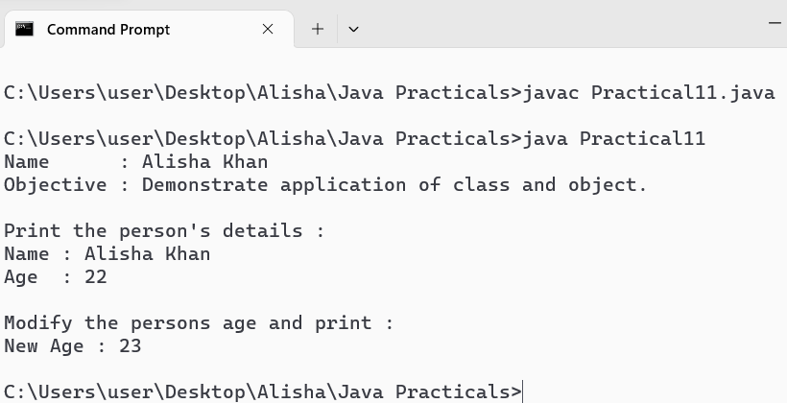

WAJP to demonstrate method overloading.
Code :
public class Practical12 {

//Method to add two integers
public int add(int a , int b) {
return a + b;
}

//Method to add three integers
public int add(int a , int b, int c) {
return a + b + c;
}

//Method to add two doubles
public double add(double a ,double b) {
return a + b ;
}

//Method to concatenate two strings
public String add(String a, String b, String c, String d) {
return a + b + c + d;
}

public static void main(String[] args) {
System.out.println("Name : Alisha Khan");
System.out.println("Objective : Demonstrate method overloading.");

System.out.println("\nCreating a method sum and overloading the method.");
System.out.println("\nDisplaying the result :");
Practical12 obj = new Practical12();
System.out.println("\nSum of two integers : " +obj.add(5, 10));
System.out.println("Sum of three integers : " +obj.add(33, 44, 55));
System.out.println("Sum of two doubles : " +obj.add(5.5, 10.9));
System.out.println("Concatenated String : " +obj.add("K", "h", "a", "n"));
}
}

Output :

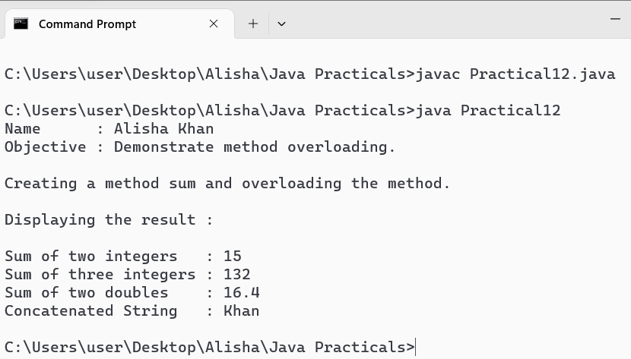

WAJP to demonstrate constructor overloading.
Code :
public class Practical13 {

// Nested static Employee class
public static class Employee {
private int id;
private String name;
private double salary;

// Default Constructor
public Employee() {
this.id = 101;
this.name = "Alisha";
this.salary = 50000.0;
}

// Parameterized Constructor with default argument
public Employee(int id, String name) {
this.id = id;
this.name = name;
this.salary = 40000.0;
}

// Parameterized constructor
public Employee(int id, String name, double salary) {
this.id = id;
this.name = name;
this.salary = salary;
}

// Methods to display employee details
public void display() {
System.out.println("Employee ID : " + id);
System.out.println("Employee Name : " + name);
System.out.println("Employee Salary : $" + salary);
}
}

public static void main(String[] args) {
System.out.println("Name : Alisha Khan");
System.out.println("Objective : Demonstrate constructor overloading.");

// Creating objects using different constructors
Employee emp1 = new Employee();
Employee emp2 = new Employee(102, "Juhi");
Employee emp3 = new Employee(103, "Keshar", 30000);

// Display Employee details
System.out.println("\nEmployee 1 :");
emp1.display();
System.out.println();

System.out.println("Employee 2 :");
emp2.display();
System.out.println();

System.out.println("Employee 3 :");
emp3.display();
System.out.println();
}
}

Output :

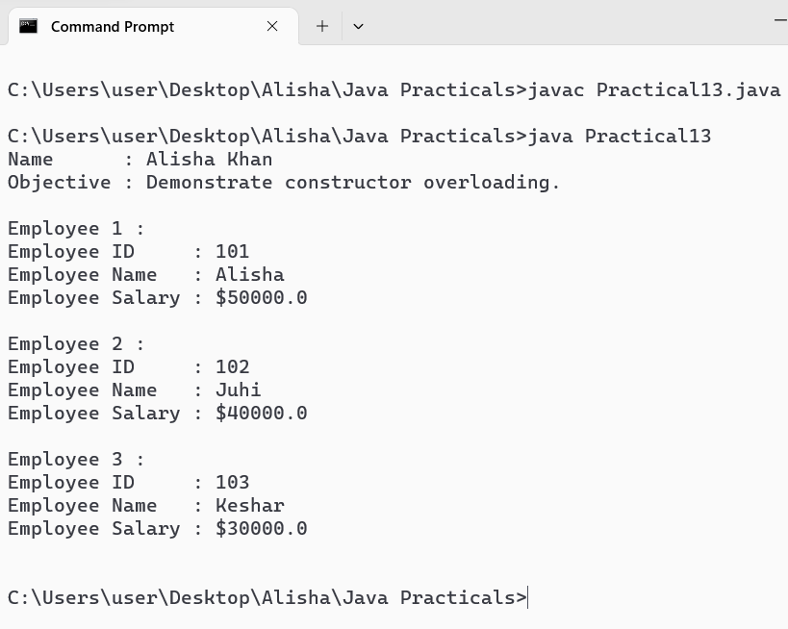

WAJP using single inheritance.
Code :
class RBI
{
public void CentralBank() {
System.out.println("\nParent Class : ");
System.out.println("Reserve Bank of India.");
}
}
class Kotak extends RBI
{
public void ChildBank() {
System.out.println("\nChild class : ");
System.out.println("Kotak Mahindra Bank");
}
}

public class Practical14
{
public static void main(String[] args) {
System.out.println("Name : Alisha Khan");
System.out.println("Objective : Demonstrate Single Inheritance.");
Kotak obj1 = new Kotak();
obj1.CentralBank();
obj1.ChildBank();
}
}

Output :

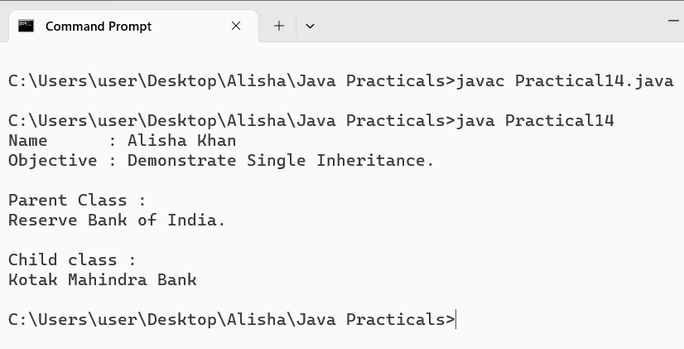

WAJP using super and this keyword.
Code :
//The Parent class
class Parent {
String name;

Parent(String name) {
this.name = name;
}

void display() {
System.out.println("Name : " +name);
}
}

//The Child class
class Child extends Parent {
int age;
String favoriteColor ;

Child(String name, int age, String favoriteColor) {
super(name);
this.age = age;
this.favoriteColor = favoriteColor;
}

void display() {
super.display();
System.out.println("Age : " +age);
System.out.println("Favorite Color : " +favoriteColor);
}
}

public class Practical15 {
public static void main(String[] args) {

System.out.println("Name : Alisha Khan");
System.out.println("Objective : Demonstrate use of super and this class.");

//Create an instance of the Child Class
Child child = new Child("Alisha", 22, "Black");

//Call the display() method of the Child class
child.display();
}
}

Output :

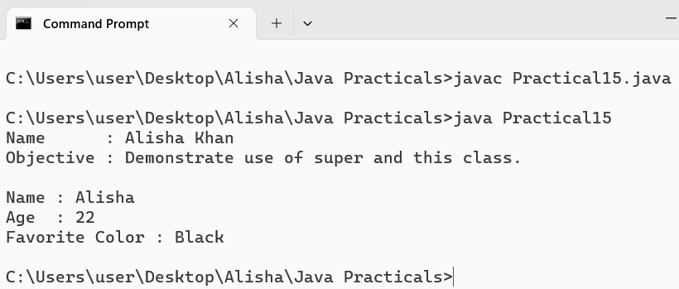

WAJP to demonstrate multilevel inheritance.
Code :
//Base class
class Bicycle{
void displayFeatures() {
System.out.println("\nBicycle Features : Pedals, Manual power");
}
}

//Inherits from Bicycle and adds an engine
class Motorbike extends Bicycle {
void displayFeatures()
{
super.displayFeatures(); //Display features of Bicycle
System.out.println("\nAdded feature by Motorbike : Engine");
}
}

//inherits from Motorbike and integrates an electric motor
class ElectricBike extends Motorbike {
void displayFeatures()
{
System.out.println("\nNew feature by ElectricBike : Electric motor and battery");
}
}

//Main class
public class Practical16 {
public static void main(String[] args)
{
System.out.println("Name : Alisha Khan");
System.out.println("Objective : Demonstrate Multilevel Inheritance.");

ElectricBike myEbike = new ElectricBike();
myEbike.displayFeatures();
}
}

Output :

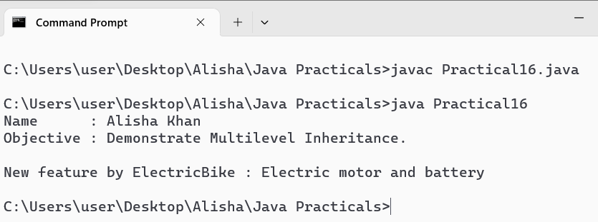

WAJP to demonstrate method overriding.
Code :
//Parent Class
class Bank{
int getRateofInterest()
{
return 2 ;
}
}
//Child class 1
class SBI extends Bank{
int getRateofInterest()
{
System.out.println("\nOverriding Base class method through Child class 1.");
return 8;
}
}
//child class 2
class ICICI extends Bank{
int getRateofInterest()
{
System.out.println("\nOverriding Base class method through Child class 2.");
return 7;
}
}
public class Practical17
{
public static void main(String[] args)
{
System.out.println("Name : Alisha Khan");
System.out.println("Objective : Demonstrate Method Overriding.");

SBI s = new SBI();
ICICI I = new ICICI();
System.out.println("SBI rate of Interest : " + s.getRateofInterest());
System.out.println("ICICI rate of Interest : " + I.getRateofInterest());
}
}

Output :

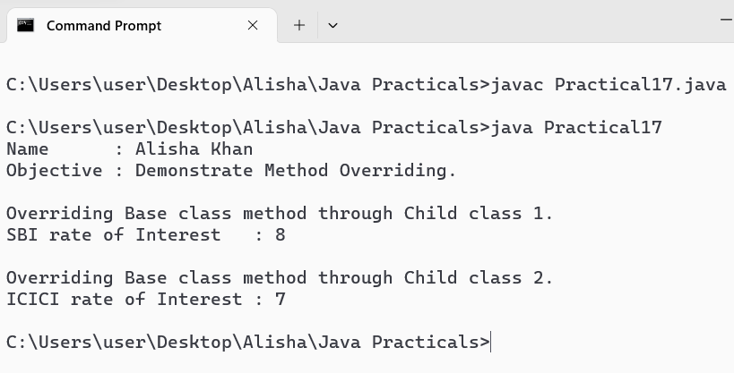

WAJP using multiple inheritance concept through interfaces.
Code :
interface LightControl {
void turnOnLight();
void turnOffLight();
}

interface ClimateControl {
void setTemp(int temp);
}

class SmartHome implements LightControl, ClimateControl{
@Override
public void turnOnLight(){
System.out.println("Lights ON.");
}
@Override
public void turnOffLight(){
System.out.println("Lights OFF.");
}
@Override
public void setTemp(int temp){
System.out.println("Temperature set to : " + temp + " Degree.");
}
}

public class Practical18 {
public static void main(String[] args){
System.out.println("Name : Alisha Khan");
System.out.println("Objective : Demonstrate multiple inheritance through interfaces.");

SmartHome obj = new SmartHome();
System.out.println("\nManaging Smart Home devices : \n");
obj.turnOnLight();
obj.setTemp(22);
obj.turnOffLight();
}
}

Output :

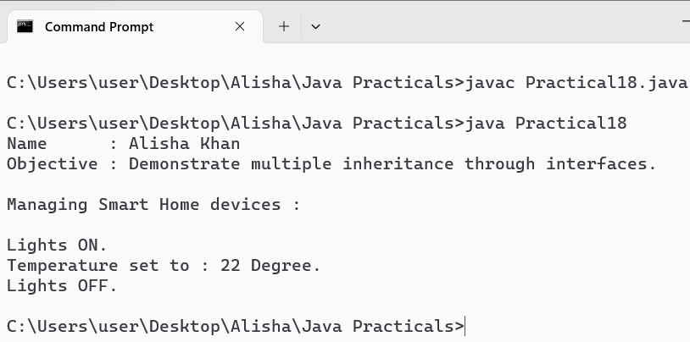

WAJP to demonstrate the concept of inner class.
Code :
class Outerclass {
private int outerVar = 10;

class Innerclass {
void display(){
System.out.println("\nValue of Outer class variable : " + outerVar);
}
}
}
public class Practical19 {
public static void main(String[] args) {
System.out.println("Name : Alisha Khan");
System.out.println("Objective : Demonstrate the concept of inner class.");

Outerclass obj1 = new Outerclass();
Outerclass.Innerclass obj2 = obj1.new Innerclass();
obj2.display();
}
}

Output :

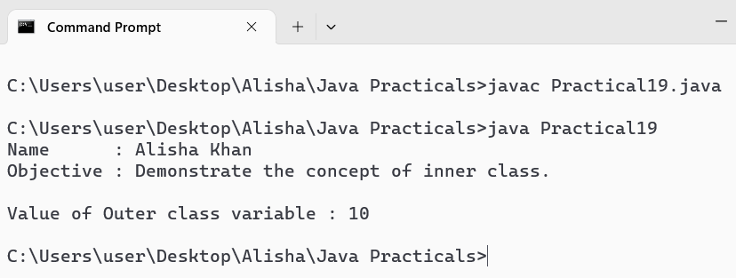

WAJP to demonstrate the concept of local class.
Code :
public class Practical20 {
private static int staticVar = 10;

public void outerMethod() {
final int localVar = 20; //constant local variable

//Local class defined within the method
class LocalClass
{
void display()
{
System.out.println("\nStatic variable : " + staticVar);
System.out.println("Local Variable : " + localVar);
}
}

LocalClass localobj = new LocalClass();
localobj.display();
}
public static void main(String[] args){
System.out.println("Name : Alisha Khan");
System.out.println("Objective : Demonstrate the concept of local class.");

Practical20 demo = new Practical20();
demo.outerMethod();
}
}
Output :

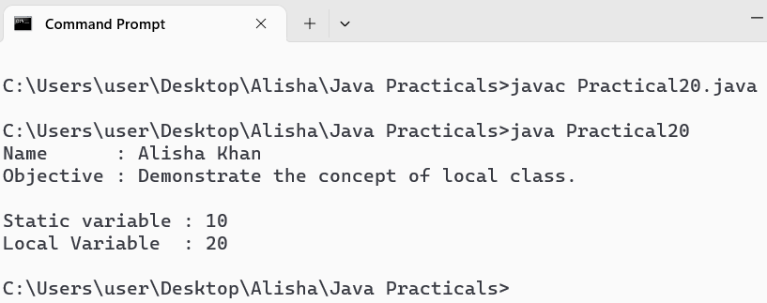

WAJP that creates its own package containing two classes.
Code :
// create a new directory called mathoperations
// and save the Addition and Subtraction files in it

//Addition.java
package mathoperations;

public class Addition {
public int add(int a, int b) {
return a + b;
}
}
//Subtraction.java
package mathoperations;

public class Subtraction {
public int subtract(int a, int b) {
return a - b;
}
}

//Practical21.java
import mathoperations.*;
import java.util.Scanner;

public class Practical21 {
public static void main(String[] args) {
System.out.println("Name : Alisha Khan");
System.out.println("Objective : Create a Package containing two classes.");

Scanner sc = new Scanner(System.in);

System.out.print("Enter first number : ");
int num1 = sc.nextInt();

System.out.print("Enter second number : ");
int num2 = sc.nextInt();

Addition addition = new Addition();
Subtraction subtraction = new Subtraction();

int sum = addition.add(num1, num2);
int difference = subtraction.subtract(num1, num2);

System.out.println("\nDisplay Result:");
System.out.println("Addition of " + num1 + " and " + num2 + " is : " + sum);
System.out.println("Subtraction of " + num1 + " and " + num2 + " is : " + difference);
}
}

Output :

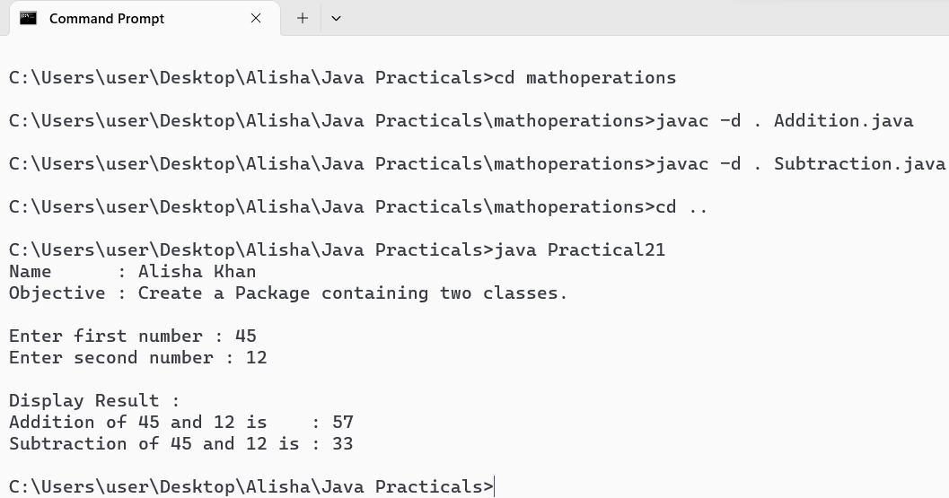

WAJP using try and catch statement.
Code :
import java.util.Scanner;

class BankAccount {
private double balance;

public BankAccount(double initialBalance){
this.balance = initialBalance;
}
public void deposit(double amount) {
if (amount <= 0) throw new IllegalArgumentException("Deposit amount must be positive");
balance += amount;
}
public double getBalance() {
return balance;
}
}

public class Practical22{
public static void main(String[] args) {
System.out.println("Name : Alisha Khan");
System.out.println("Objective : Demonstrate try and catch statement.");

Scanner sc = new Scanner(System.in);
BankAccount ac = new BankAccount(500.0);

try {
System.out.println("\nEnter deposit amount : ");
ac.deposit(sc.nextDouble());
System.out.println("\nFinal balance : $" + ac.getBalance());
}
catch(IllegalArgumentException e){
System.out.println("Error: " + e.getMessage());
}
finally {
sc.close();
System.out.println("Transaction complete.");
}
}
}

Output :

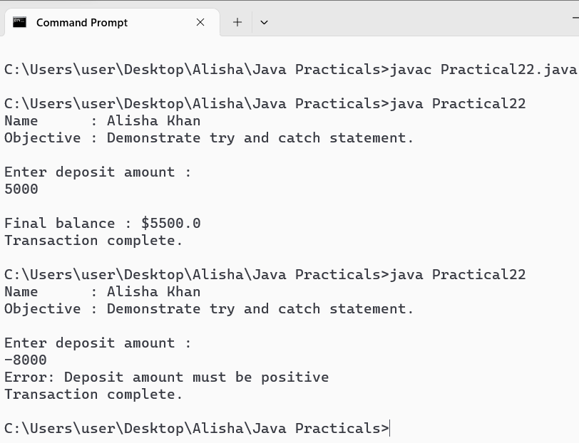

WAJP using multiple catch statements.
Code :
import java.util.Scanner;

public class Practical23 {
public static void main(String[] args){
System.out.println("Name : Alisha Khan");
System.out.println("Objective : Demonstrate use of multiple catch statements.");

Scanner sc = new Scanner(System.in);

try {
System.out.print("\nEnter Numerator : ");
int num = sc.nextInt();

System.out.print("Enter Denomenator : ");
int den = sc.nextInt();

int result = num / den;
System.out.println("\nResult : " + result);
}
catch(ArithmeticException e){
System.out.println("\nError : Division by zero is not allowed.");
}
catch(NumberFormatException e) {
System.out.println("\nError : Invalid input. Please enter valid integers");
}
catch(Exception e) {
System.out.println("\nError : An unexpected error occured.");
}
finally {
sc.close();
}
}
}

Output :

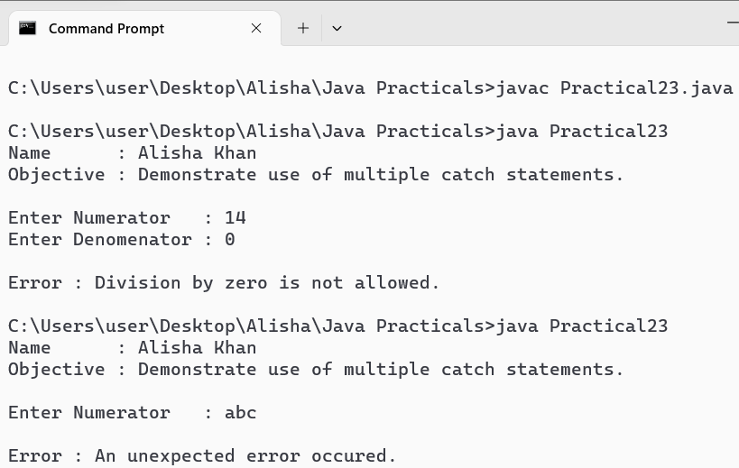

WAJP to demonstrate the multicatch feature.
Code :
import java.util.Scanner;

public class Practical24 {
public static void main(String[] args) {
System.out.println("Name : Alisha Khan");
System.out.println("Objective : Demonstrate the multicatch feature.");

Scanner scanner = new Scanner(System.in);

try {
System.out.print("\nEnter numerator : ");
int numerator = scanner.nextInt();

System.out.print("Enter denominator : ");
int denominator = scanner.nextInt();

int result = numerator / denominator;
System.out.println("\nDivision Result : " + result);
} catch (ArithmeticException | java.util.InputMismatchException e) {
System.out.println("\nError: " + e.getMessage());
} finally {
scanner.close();
}
}
}
Output :

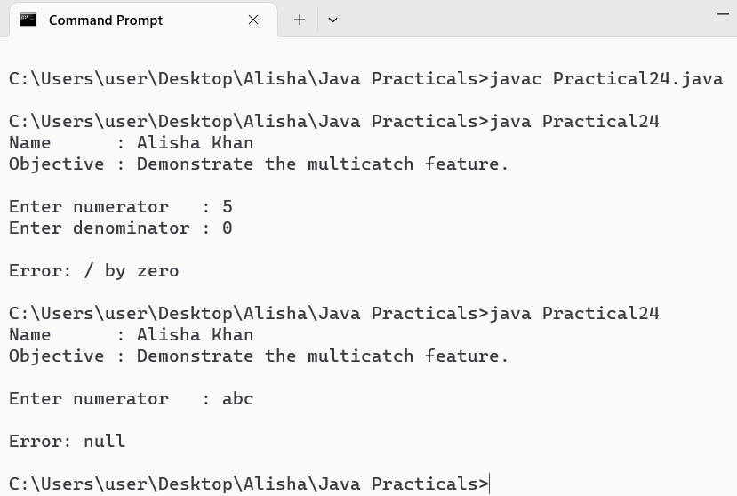

WAJP to demonstrate the use of finally block.
Code :
class Practical25{
public static void main(String[] args) {
System.out.println("Name : Alisha Khan");
System.out.println("Objective : Demonstrate the use of finally block.");

System.out.println("\nStarting the program.");
try {
System.out.println("Inside the try block.");
// This will cause a divide by zero exception
System.out.println("\nTrying to divide 10 by 0 : 10 / 0");
int result = 10 / 0;
System.out.println("Result: " + result);
} catch (ArithmeticException e) {
System.out.println("\nInside the catch block : Error : " + e.getMessage());
} finally {
System.out.println("\nInside the finally block. This will always execute.");
}
System.out.println("\nEnd of the program.");
}
}

Output :

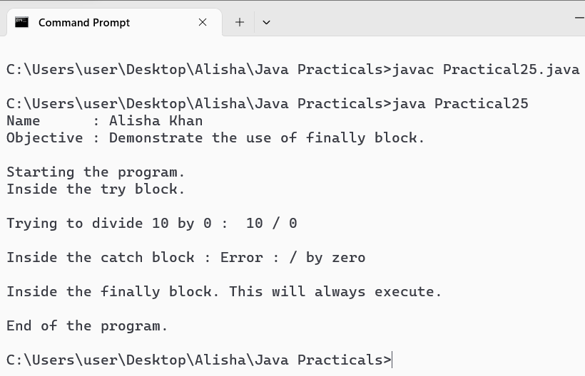

WAJP using nested try statements.
Code :
public class Practical26 {
public static void main(String[] args) {

System.out.println("Name : Alisha Khan");
System.out.println("Objective : Demonstrate the use of nested try statements.");

try {
System.out.println("\nEntering outer try block.");

try {
System.out.println("Entering inner try block.");
System.out.println("Dividing 5 by 0 : 5 / 0");
int a = 5 / 0; // This will cause ArithmeticException
}
catch (ArithmeticException e) {
System.out.println("Error: Caught ArithmeticException in inner try block.");
}

try {
System.out.println("\nEntering inner try block 2.");
int arr[] = new int[5];
arr[10] = 7; // This will cause ArrayIndexOutOfBoundsException
}
catch (ArrayIndexOutOfBoundsException e) {
System.out.println("Error: Caught ArrayIndexOutOfBoundsException in inner try block 2: " + e.getMessage());
}

System.out.println("\nExiting outer try block normally.");
}
catch (Exception e) {
System.out.println("Caught an exception in outer try block: " + e.getMessage());
}
finally {
System.out.println("Entering finally block. This will always execute.");
}

System.out.println("End of program.");
}
}

Output :

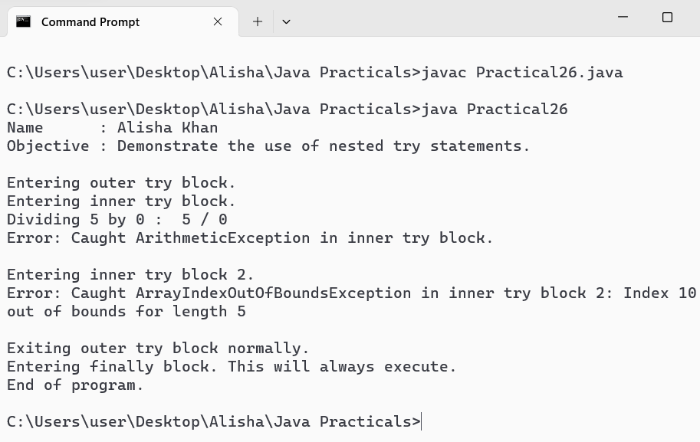

WAJP to create your own exception class and display corresponding error message.
Code :
class MycutomException extends Exception {
public MycutomException(String message) {
super(message);
}
}

class Practical27 {
public static void ValidAge(int age) throws MycutomException {
if(age < 18) {
throw new MycutomException("\nAge must be 18 or older.");
}
System.out.println("Age is valid.");
}
public static void main(String[] args) {
System.out.println("Name : Alisha Khan");
System.out.println("Objective : Demonstrate the use of a custom exception class.");

try {
System.out.println("\nCheck the age if age is valid or not : ");
System.out.println("Age : 16");
ValidAge(16);
}
catch(MycutomException e) {
System.out.println("Caught custom exception : " +e.getMessage());
}
try {
System.out.println("\nAge : 20");
ValidAge(20);
}
catch(MycutomException e) {
System.out.println("Caught custom exception : " + e.getMessage());
}
System.out.println("End of program.");
}
}

Output :

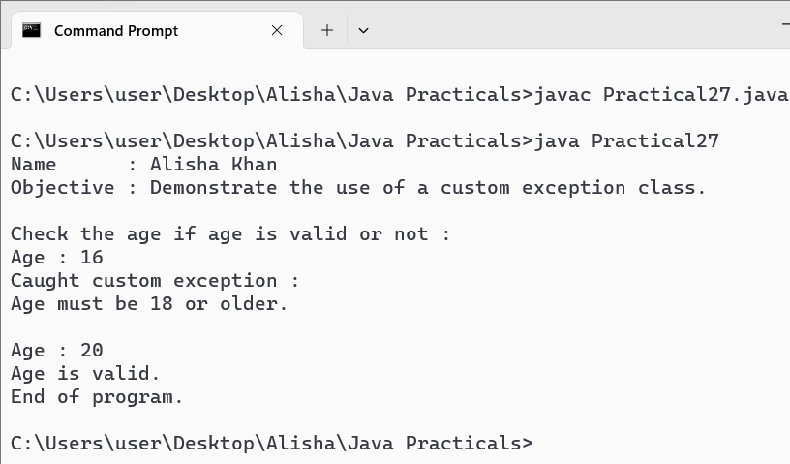

WAJP for creating and exception threads by extending the thread class.
Code :
class CustomException extends Exception {
public CustomException(String message) {
super(message);
}
}
//Custom thread class that throws ane exception
class Mythread extends Thread {
@Override
public void run() {
try {
System.out.println("\nThread is running.");
throw new CustomException("Custom Exception thrown from thread.");
}
catch(CustomException e) {
System.out.println("Caught CustomException in thread : " + e.getMessage());
}
}
}
class Practical28 {
public static void main(String[] args) {
System.out.println("Name : Alisha Khan");
System.out.println("Objective : Demonstrate creating exception threads by extending the Thread class.");
Mythread thread = new Mythread();
thread.start();

System.out.println("Main thread continues to run.");
System.out.println("End of program.");
}
}
Output :

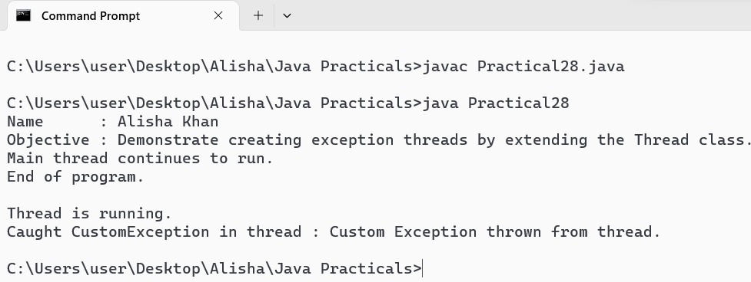

WAJP to run three threads by implementing the runnable interface.
Code :
class Mythread1 implements Runnable {
public void run() {
for(int i=0; i<=5; i++){
System.out.println("Thread 1 is running : " +(i+1) +" Time");
}
}
}
class Mythread2 implements Runnable {
public void run() {
for(int i=0; i<=5; i++){
System.out.println("Thread 2 is running : " +(i+1) +" Time");
}
}
}

public class Practical29 {
public static void main(String[] args) {
System.out.println("Name : Alisha Khan");
System.out.println("Objective : Demonstrate running three threads by implementing Runnable interface.\n");

Mythread1 b1 = new Mythread1();
Thread g1 = new Thread(b1);

Mythread2 b2 = new Mythread2();
Thread g2 = new Thread(b2);

g1.start();
g2.start();
}
}

Output :

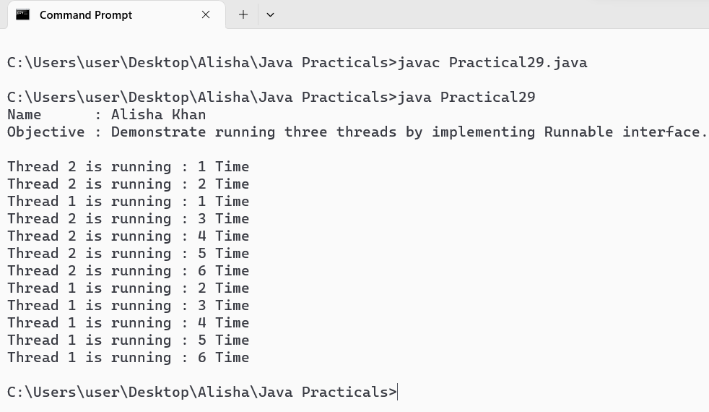

WAJP to demonstrate the use of join() method.
Code :
class Mythread1 implements Runnable {
public void run() {
for(int i=0; i<5; i++){
System.out.println("Thread 1 is running : " +(i+1) +" Time");
}
}
}
class Mythread2 implements Runnable {
public void run() {
for(int i=0; i<5; i++){
System.out.println("Thread 2 is running : " +(i+1) +" Time");
}
}
}

public class Practical30 {
public static void main(String[] args) {
System.out.println("Name : Alisha Khan");
System.out.println("Objective : Demonstrate the use of join() method.\n");

Mythread1 b1 = new Mythread1();
Thread g1 = new Thread(b1);

Mythread2 b2 = new Mythread2();
Thread g2 = new Thread(b2);

g1.start();
try {
g1.join();
}
catch(Exception e) {
System.out.println(e);
}
System.out.println("\n");
g2.start();
}
}

Output :

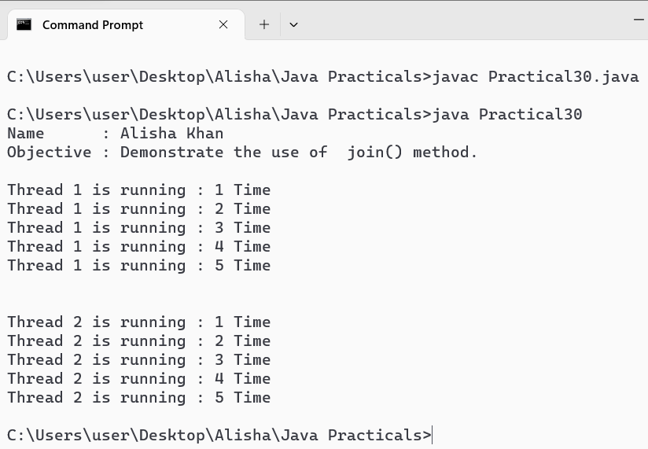

WAJP to demonstrate multithreading using wait() and notify().
Code :
class SharedResource {
private boolean Thread1turn = true;

public synchronized void thread1Task() {
for (int i = 0; i < 5; i++) {
try {
while (!Thread1turn) {
System.out.println("Thread 1 is waiting...");
wait();
}
System.out.println("Thread 1 is running : " + (i + 1) + " Time");
Thread1turn = false;
System.out.println("Thread 1 is notifying Thread 2...");
notify();
} catch (InterruptedException e) {
Thread.currentThread().interrupt();
}
}
}

public synchronized void thread2Task() {
for (int i = 0; i < 5; i++) {
try {
while (Thread1turn) {
System.out.println("Thread 2 is waiting...");
wait();
}
System.out.println("Thread 2 is running : " + (i + 1) + " Time");
Thread1turn = true;
System.out.println("Thread 2 is notifying Thread 1...");
notify();
} catch (InterruptedException e) {
Thread.currentThread().interrupt();
}
}
}
}

class MyThread1 extends Thread {
private SharedResource resource;

public MyThread1(SharedResource resource) {
this.resource = resource;
}

public void run() {
resource.thread1Task();
}
}

class MyThread2 extends Thread {
private SharedResource resource;

public MyThread2(SharedResource resource) {
this.resource = resource;
}

public void run() {
resource.thread2Task();
}
}

public class Practical31 {
public static void main(String[] args) {
System.out.println("Name : Alisha Khan");
System.out.println("Objective : Demonstrate the use of wait() and notify().\n");

SharedResource resource = new SharedResource();

MyThread1 t1 = new MyThread1(resource);
MyThread2 t2 = new MyThread2(resource);

t1.start();
t2.start();
}
}

Output :

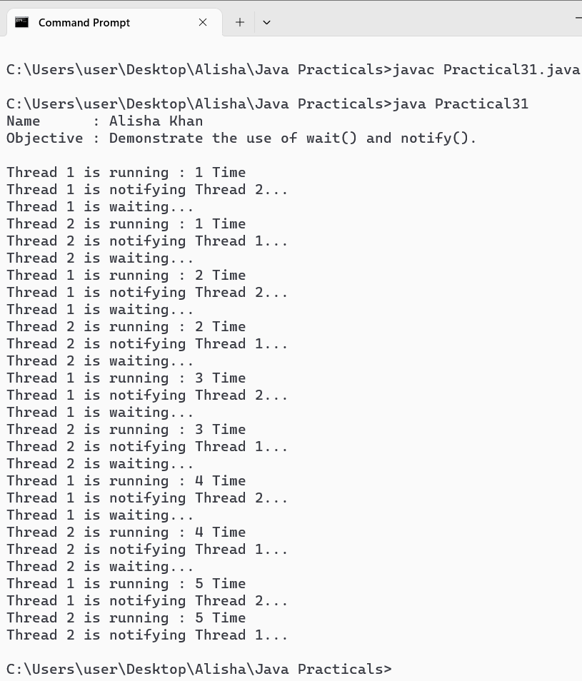

WAJP to demonstrate the string class & its methods.
Code :
public class Practical32 {
public static void main(String[] args) {
System.out.println("Name : Alisha Khan");
System.out.println("Objective : Demonstrate the use of String class and its methods.\n");

String str1 = "Hello";
String str2 = "World";
String str3 = "Hello";

// Length of a string
System.out.println("Length of str1 : " + str1.length());

// Concatenation
String concatStr = str1.concat(" ").concat(str2);
System.out.println("Concatenated string : " + concatStr);

// Character at index
char charAtIndex = str1.charAt(1);
System.out.println("Character at index 1 in str1 : " + charAtIndex);

// Comparison
System.out.println("\nComparing str1 and str2 : " + str1.equals(str2));
System.out.println("Comparing str1 and str3 : " + str1.equals(str3));

// Substring
String substring = str2.substring(0, 3);
System.out.println("Substring of str2 from index 0 to 3: " + substring);

// Index of a character
int index = str2.indexOf('r');
System.out.println("Index of 'r' in str2 : " + index);

// Convert to uppercase and lowercase
String upperCaseStr = str1.toUpperCase();
System.out.println("\nUppercase of str1 : " + upperCaseStr);

String lowerCaseStr = str2.toLowerCase();
System.out.println("Lowercase of str2 : " + lowerCaseStr);

// Replace characters
String replacedStr = str1.replace('l', 'p');
System.out.println("Replacing 'l' with 'p' in str1: " + replacedStr);

// Split string
String splitStr = "Java is awesome";
String[] splitArray = splitStr.split(" ");
System.out.print("Splitting string by space : ");
for (String s : splitArray) {
System.out.print(s + ", ");
}

// Trim whitespace
String stringWithWhitespace = " Hello ";
String trimmedStr = stringWithWhitespace.trim();
System.out.println("\nTrimmed string : " + trimmedStr);

// Check if string starts/ends with specific substring
System.out.println("Does str1 start with 'He'? : " + str1.startsWith("He"));
System.out.println("Does str2 end with 'ld'? : " + str2.endsWith("ld"));
}
}

Output :

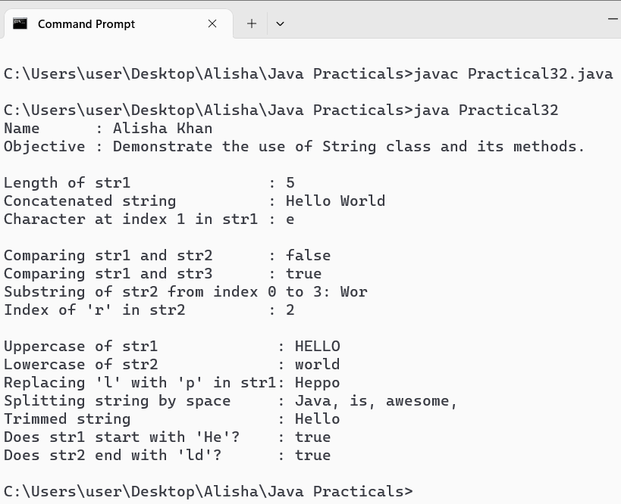

WAJP to demonstrate StringBuffer class and its methods.
Code :
public class Practical33 {
public static void main(String[] args) {
System.out.println("Name : Alisha Khan");
System.out.println("Objective : Demonstrating StringBuffer class and its methods\n");

// Initial string
String initialString = "Hello";
System.out.println("Initial String : " + initialString);

//Create a class object
StringBuffer SB = new StringBuffer("Hello");

//Append text to the StringBuffer
SB.append("World");
System.out.println("After appending : " +SB);

//Insert text at a specific position
SB.insert(5, ",");
System.out.println("After appending : " +SB);

//Replace text
SB.replace(6, 11, "Java");
System.out.println("After appending : " +SB);

//Delete characters
SB.delete(0, 5);
System.out.println("After appending : " +SB);

//Reverse the content
SB.reverse();
System.out.println("After appending : " +SB);

//Get the length of stringBuffer
System.out.println("Length of StringBuffer : " +SB.length());

//Set the length of StringBuffer
SB.setLength(5);
System.out.println("After setting length : " +SB);

//Get characters at a specific index
System.out.println("Character at length 2 : " +SB.charAt(2));

//Get substring
System.out.println("Substring : " + SB.substring(1, 3));
}
}

Output :

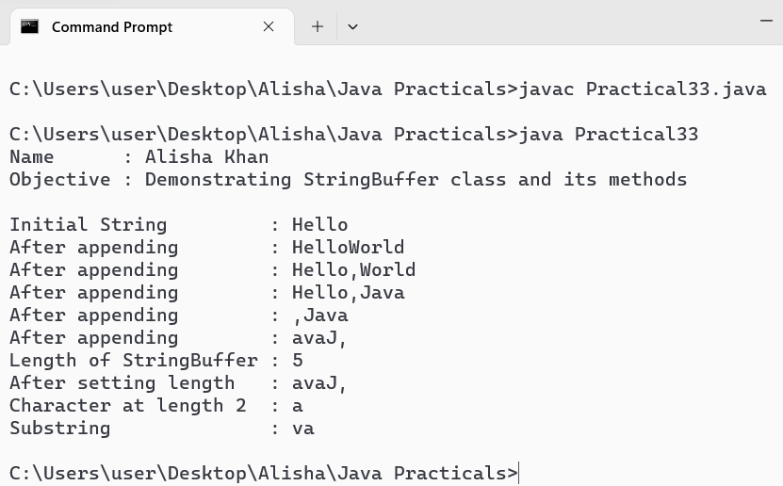

WAJP to demonstrate various wrapper classes.
Code :
public class Practical34 {
public static void main(String[] args) {
System.out.println("Name : Alisha Khan");
System.out.println("Objective : Demonstrating various wrapper classes and their methods\n");

Integer intWrapper = 10;
Double doubleWrapper = 3.14;
Character charWrapper= 'A';
Boolean boolWrapper = true;

System.out.println("Displaying values and methods of Integer wrapper class : ");
System.out.println("Value : " + intWrapper);
System.out.println("Max Value : " + Integer.MAX_VALUE);
System.out.println("Min Value : " + Integer.MIN_VALUE);
System.out.println("Binary String : " + Integer.toBinaryString(intWrapper));
System.out.println("Hex String : " + Integer.toHexString(intWrapper));
System.out.println();

System.out.println("Displaying values and methods of Double wrapper class : ");
System.out.println("Value : " + doubleWrapper);
System.out.println("Max Value : " + Double.MAX_VALUE);
System.out.println("Min Value : " + Double.MIN_VALUE);
System.out.println("Nan : " + Double.NaN);
System.out.println("Infinity : " + Double.POSITIVE_INFINITY);
System.out.println("Is NaN? : " + Double.isNaN(doubleWrapper));
System.out.println("Is Infinite ? : " + Double.isInfinite(doubleWrapper));
System.out.println("");

System.out.println("Displaying values and methods of Character wrapper class : ");
System.out.println("Value : " + charWrapper);
System.out.println("Is Digit : " + Character.isDigit(charWrapper));
System.out.println("Is Letter : " + Character.isLetter(charWrapper));
System.out.println("Is Whitespace : " + Character.isWhitespace(charWrapper));
System.out.println();

System.out.println("Displaying values and methods of Boolean wrapper class : ");
System.out.println("Value : " + boolWrapper);
System.out.println("Boolean.TRUE : " + Boolean.TRUE);
System.out.println("Boolean.FALSE : " + Boolean.FALSE);

System.out.println();
}
}

Output :

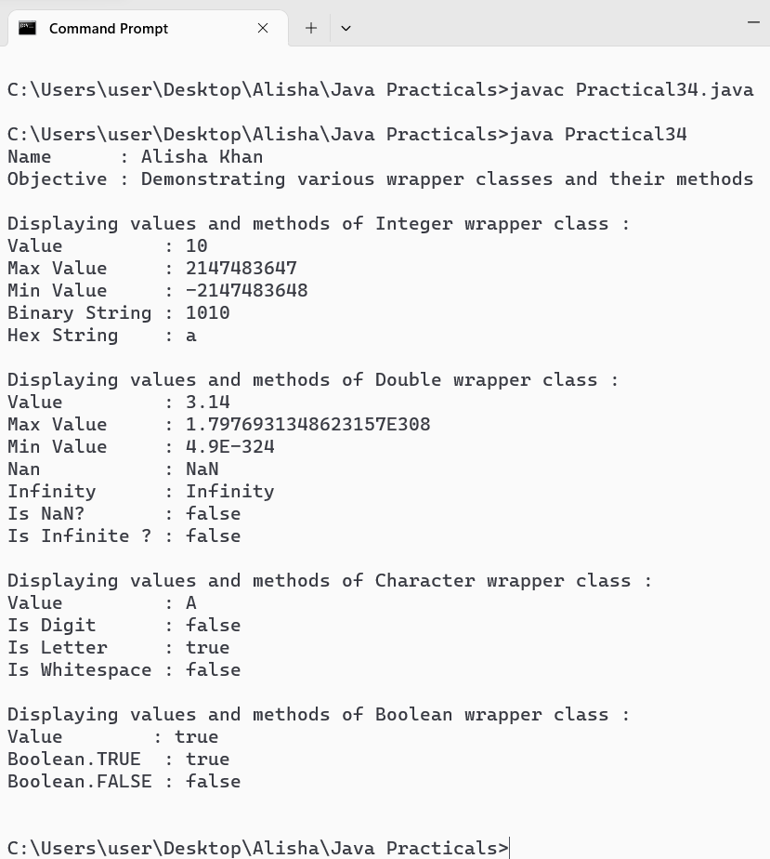

WAJP to demonstrate HashSet class and its methods.
Code :
import java.util.HashSet;
public class Practical35 {
public static void main(String[] args) {
System.out.println("Name : BookHashSetDemo");
System.out.println("Objective : Demonstrating HashSet class and its methods.\n");

//Creating a HashSet to store book
HashSet<String> bookset = new HashSet<>();

//Adding book names to the HashSet
bookset.add("Java Programming");
bookset.add("Data structure and Algorithm");
bookset.add("Introduction to Algorithms");
bookset.add("Clean code");
bookset.add("Design Patterns");

//Displaying the book names in HashSet
System.out.println("Books in HashSet : ");
int count = 1;
for(String book : bookset) {
System.out.println(count + "." + book);
count++;
}

System.out.println("\nChecking if a book exists in the HashSet : ");
String searchBook = "Clean code";
if(bookset.contains(searchBook)) {
System.out.println(searchBook + " is available in the Library." );
}
else {
System.out.println(searchBook + " is not available in the Library.");
}

System.out.println("\nRemoving a book from the HashSet : ");
String removeBook = "Introduction to Algorithms";
if (bookset.remove(removeBook)) {
System.out.println(removeBook + " has been removed from the library.");
}
else {
System.out.println(removeBook + " was not found in the library.");
}

System.out.println("\nBook Names in HashSet after removal : ");
int i = 1;
for(String book : bookset) {
System.out.println(i + "." + book);
i++;
}
System.out.println("\nTotal number of books in the library: " + bookset.size());
}
}

Output :

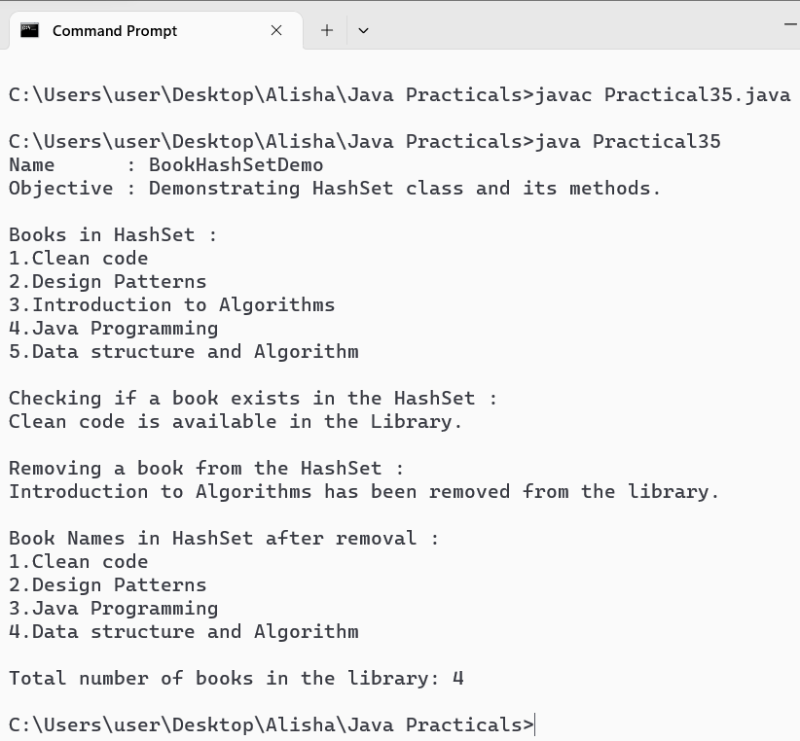

WAJP to demonstrate ArrayList class & its methods.
Code :
import java.util.ArrayList;

public class Practical36 {
public static void main(String[] args) {
System.out.println("Name : ComputerArrayListDemo");
System.out.println("Objective : Demonstrating ArrayList class and its methods.\n");

// Creating an ArrayList to store computer models
ArrayList<String> computerList = new ArrayList<>();

// Adding computer models to the ArrayList
computerList.add("HP Pavilion");
computerList.add("Dell XPS");
computerList.add("Lenovo ThinkPad");
computerList.add("Apple MacBook Pro");

// Displaying the computer models in the ArrayList
System.out.println("Computer Models in ArrayList : ");
int count = 1;
for (String model : computerList) {
System.out.println(count + "." + model);
count++;
}

System.out.println("\nChecking if a computer model exists in the ArrayList : ");
String searchModel = "Dell XPS";
if (computerList.contains(searchModel)) {
System.out.println(searchModel + " is available in the list.");
} else {
System.out.println(searchModel + " is not available in the list.");
}

System.out.println("\nRemoving a computer model from the ArrayList : ");
String removeModel = "Lenovo ThinkPad";
if (computerList.remove(removeModel)) {
System.out.println(removeModel + " has been removed from the list.");
} else {
System.out.println(removeModel + " was not found in the list.");
}

System.out.println("\nComputer Models in ArrayList after removal : ");
int i = 1;
for (String model : computerList) {
System.out.println(i + "." + model);
i++;
}
System.out.println("\nTotal number of computer models in the list: " + computerList.size());
}
}

Output :

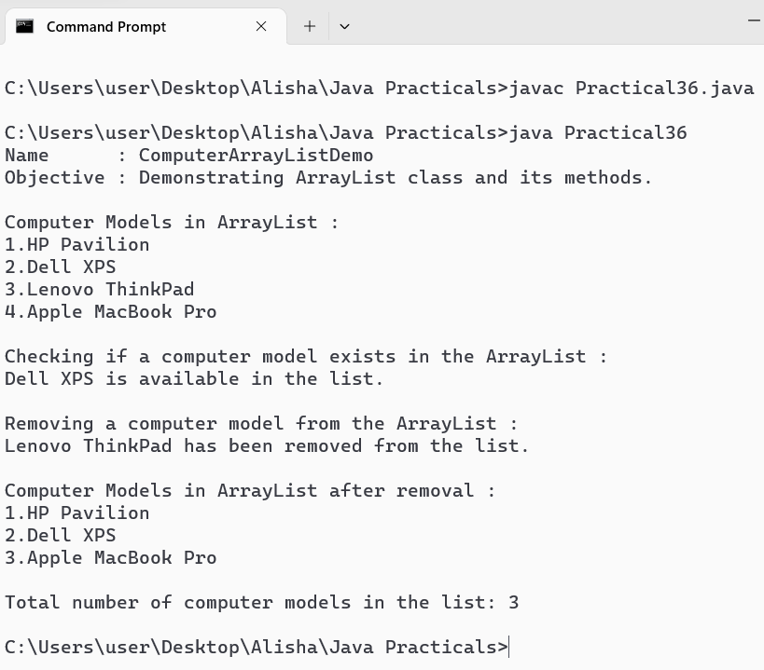

WAJP to copy a file.
Code :
import java.nio.file.Files;
import java.io.IOException;
import java.io.File;

public class Practical37 {
public static void main(String[] args) {
System.out.println("Name : Alisha Khan");
System.out.println("Objective : Copy a file.\n");

//Creating two channels one input and one output
File srcFile = new File("src.txt");
File destFile = new File("dest.txt");

try {
//using copy(InputStream, Path Target); method
Files.copy(srcFile.toPath(), destFile.toPath());
System.out.println("File copied successfully!");
}
catch(IOException e) {
System.err.println("An error occurred while copying the file: " + e.getMessage());
}
}
}

Output :

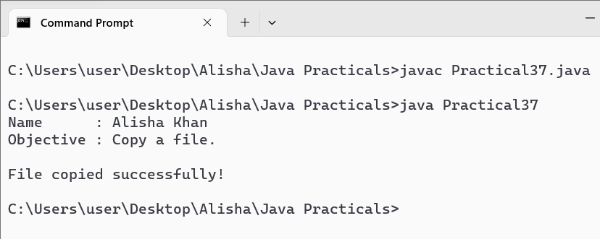

There are two files : 1. src.txt, 2. dest.txt

Files before copying :

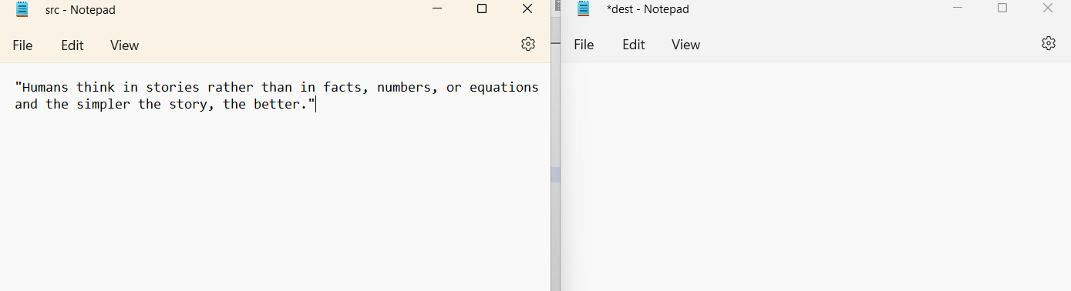

Files after copying :

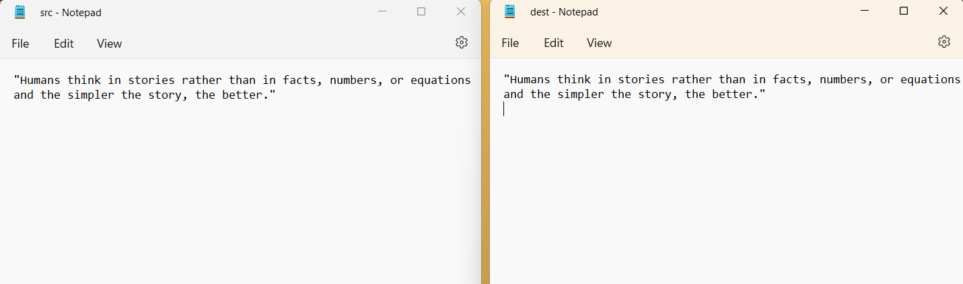

WAJP to count the number of characters in a file.
Code :
import java.io.*;

class Practical38 {
public static void main(String[] args) {
System.out.println("Name : Alisha Khan");
System.out.println("Objective : Count the number of characters in a file.\n");

int lineCount = 0;
int wordCount = 0;
int charCount = 0;

try {
// Create a FileReader object to read from the file
FileReader fr = new FileReader("src.txt");

// Wrap the FileReader in a BufferedReader to efficiently read text from the file
BufferedReader br = new BufferedReader(fr);

// Storing a line in a string variable
String currLine = br.readLine();

// Check if there is a line
while (currLine != null) {
lineCount++;

// Split the line based on spaces and store in an array
String words[] = currLine.split(" ");
wordCount = wordCount + words.length;

// Count no. of characters
for (String word : words) {
charCount = charCount + word.length();
}
currLine = br.readLine();
}

System.out.println("Number of lines in File : " + lineCount);
System.out.println("Number of words in File : " + wordCount);
System.out.println("Number of characters in File : " + charCount);

// Close the BufferedReader
br.close();
} catch (IOException e) {
System.out.println("An error occurred while reading the file.");
}
}
}

Output :

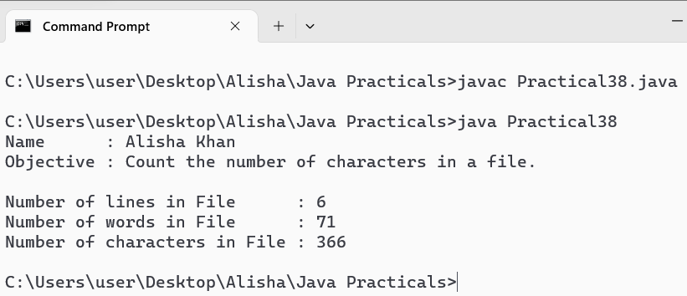

WAJP to demonstrate object serialization.
Code :
import java.io.*;
import java.util.Scanner;

class Student implements Serializable {
public int RollNo;
public String Name;

public Student(int RollNo, String Name) {
this.RollNo = RollNo;
this.Name = Name;
}
}

public class Practical39 {
public static void main(String[] args) {
System.out.println("Name : Alisha Khan");
System.out.println("Objective : Demonstrate object serialization.\n");

Scanner sc = new Scanner(System.in);

// Take user input
System.out.println("Enter Student Details : ");
System.out.print("Name : ");
String Name = sc.nextLine();
System.out.print("Roll No. : ");
int RollNo = sc.nextInt();
sc.nextLine(); // Consume the newline character

// Create a Student object
Student s1 = new Student(RollNo, Name);

// Create a file
String fileName = "Input.txt";

// Serialization
try {
FileOutputStream fos = new FileOutputStream(fileName);
ObjectOutputStream oos = new ObjectOutputStream(fos);
oos.writeObject(s1);

oos.close();

fos.close();

System.out.println("\nStudent object serialized successfully!!");
}
catch (FileNotFoundException e) {
e.printStackTrace();
}
catch (IOException e) {
e.printStackTrace();
}

// Deserialization
System.out.println("\nDo you want to Deserialize the object ? (yes/no) : ");
String choice = sc.nextLine();
if (choice.equals("yes")) { // Use .equals for string comparison
try {
FileInputStream fis = new FileInputStream(fileName);
ObjectInputStream ois = new ObjectInputStream(fis);
Student obj = (Student) ois.readObject();

System.out.println("\nStudent object Deserialized successfully");
System.out.println("\nDisplay student details : ");
System.out.println("Roll No. : " + obj.RollNo);
System.out.println("Name : " + obj.Name);

ois.close();
fis.close();
}
catch (IOException | ClassNotFoundException e) {
e.printStackTrace();
}
} else {
sc.close();
}
}
}

Output :

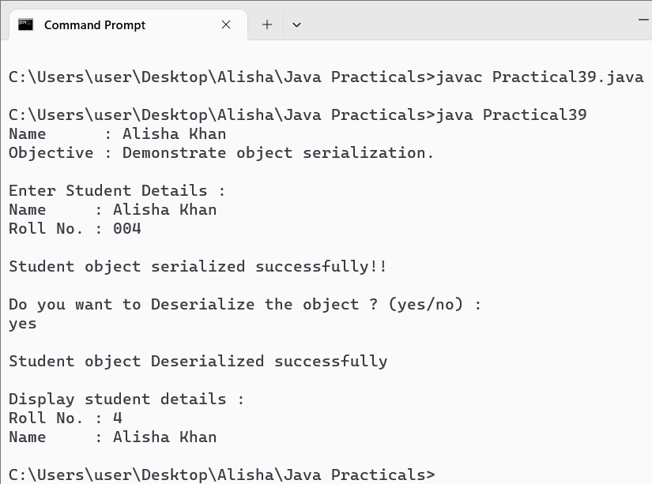

WAJP to demonstrate keyword event.
Code :
import java.awt.Color;
import java.awt.event.*;
import javax.swing.*;

public class MyFrame extends JFrame implements KeyListener {

JLabel label;
ImageIcon icon;

MyFrame() {
this.setDefaultCloseOperation(JFrame.EXIT_ON_CLOSE);
this.setSize(500, 500);
this.setLayout(null);
this.addKeyListener(this);

icon = new ImageIcon("Rocket3.png");

label = new JLabel();
label.setBounds(0, 0, 100, 100);
label.setIcon(icon);
label.setBackground(Color.black);
// label.setOpaque(true);

this.add(label);
this.setVisible(true);
}

@Override
public void keyTyped(KeyEvent e) {
switch(e.getKeyChar()) {
case 'a' : label.setLocation(label.getX()-10, label.getY());
break;
case 'w' : label.setLocation(label.getX(), label.getY()-10);
break;
case 's' : label.setLocation(label.getX(), label.getY()+10);
break;
case 'd' : label.setLocation(label.getX()+10, label.getY());
break;
}
}

@Override
public void keyPressed(KeyEvent e) {
switch(e.getKeyCode()) {
case 37 : label.setLocation(label.getX()-10, label.getY());
break;
case 38 : label.setLocation(label.getX(), label.getY()-10);
break;
case 39 : label.setLocation(label.getX()+10, label.getY());
break;
case 40 : label.setLocation(label.getX()+10, label.getY()+10);
break;
}
}

@Override
public void keyReleased(KeyEvent e) {
System.out.println("You Released key char : " + e.getKeyChar());
System.out.println("You Released key code : " + e.getKeyCode());
}

public static void main(String[] args) {
// Create and display the frame
new MyFrame();
}
}

Output :

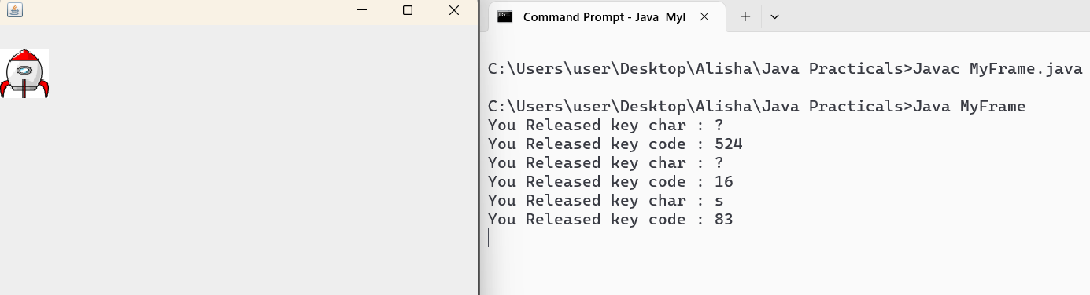

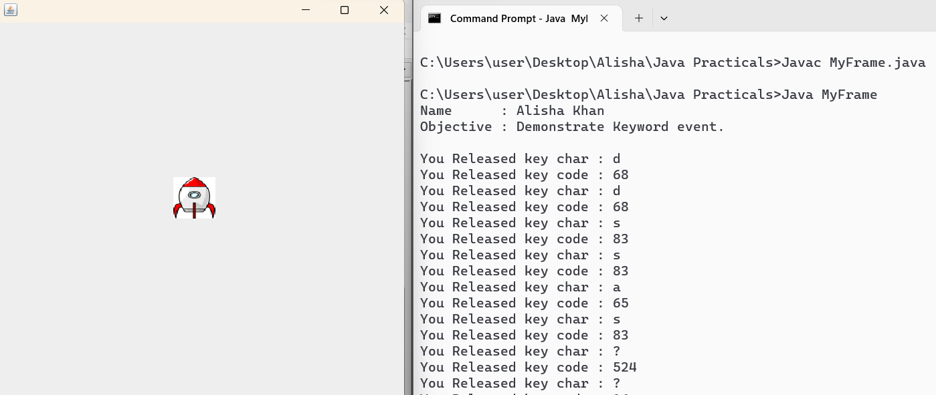

WAJP to demonstrate mouse event.
Code :
import javax.swing.*;
import java.awt.*;
import java.awt.event.*;

public class Practical41 extends JFrame implements MouseListener {
private JLabel label;

public Practical41() {
// Set up the frame
setTitle("Mouse Event Demo");
setSize(500, 500);
setDefaultCloseOperation(JFrame.EXIT_ON_CLOSE);
setLayout(null);

// Set up the label
label = new JLabel("Mouse Events");
label.setBounds(200, 200, 100, 50);
label.setOpaque(true);
label.setBackground(Color.YELLOW);
label.setHorizontalAlignment(SwingConstants.CENTER);
add(label);

// Add mouse listener
addMouseListener(this);
setVisible(true);
}

@Override
public void mouseClicked(MouseEvent e) {
label.setText("Mouse Clicked");
label.setLocation(e.getX(), e.getY());
label.setBackground(Color.ORANGE);
}

@Override
public void mousePressed(MouseEvent e) {
label.setText("Mouse Pressed");
label.setLocation(e.getX(), e.getY());
label.setBackground(Color.RED);
}

@Override
public void mouseReleased(MouseEvent e) {
label.setText("Mouse Released");
label.setLocation(e.getX(), e.getY());
label.setBackground(Color.GREEN);
}

@Override
public void mouseEntered(MouseEvent e) {
label.setText("Mouse Entered");
label.setBackground(Color.CYAN);
}

@Override
public void mouseExited(MouseEvent e) {
label.setText("Mouse Exited");
label.setBackground(Color.YELLOW);
}

public static void main(String[] args) {
System.out.println("Name : Alisha Khan");
System.out.println("Objective : Demonstrate mouse event.\n");

// Create and display the frame
SwingUtilities.invokeLater(() -> new Practical41());
}
}
Output :

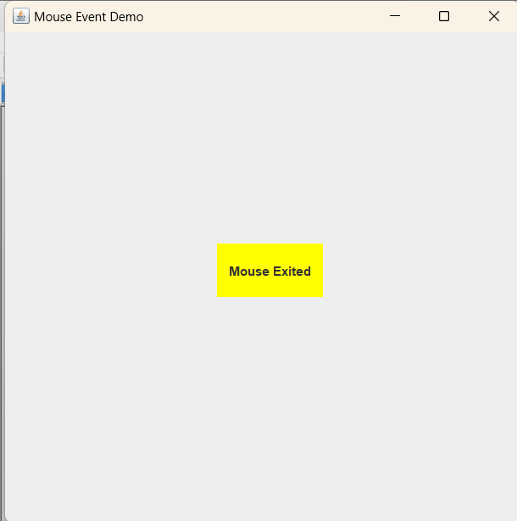

WAP to establish connection to the database.
Code :
import java.sql.Connection;
import java.sql.DriverManager;
import java.sql.SQLException;

//CLASSPATH : C:\Users\Desktop\Alisha\Java Practicals\ojdbc11.jar

public class Practical42 {
public static void main(String[] args) {
System.out.println("Name : Alisha Khan");
System.out.println("Objective : Establish connection to database.\n");

String url = "jdbc:oracle:thin:@localhost:1521:xe";
String username = "ALISHA_KHAN";
String password = "SYS1234";
try {
//Step 1 : Load the Oracle JDBC driver
Class.forName("oracle.jdbc.OracleDriver");
//Step 2 : Establish connection
Connection connect = DriverManager.getConnection(url, username, password);
System.out.println("Connected to the Oracle database!");
}
catch(ClassNotFoundException e){
System.out.println("Oracle JDBC driver not found.");
e.printStackTrace();
return;
}
catch(SQLException e) {
e.printStackTrace();
return;
}
}
}
Output :

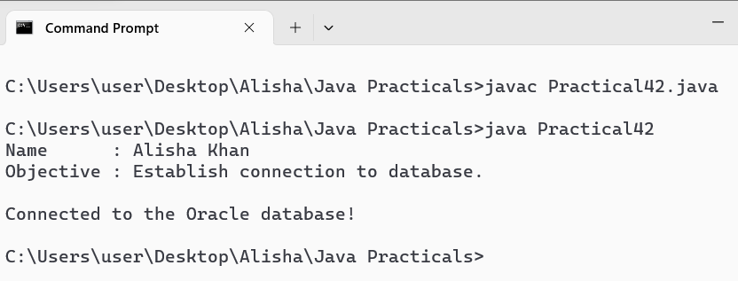

WAP to create a table named employee with fields as emp_id, emp_name, age, dept.

Code :
import java.sql.Connection;
import java.sql.DriverManager;
import java.sql.SQLException;
import java.sql.Statement;

// CLASSPATH : C:\Users\Desktop\Alisha\Java Practicals\ojdbc11.jar

public class Practical43 {
public static void main(String[] args) {
System.out.println("Name : Alisha Khan");
System.out.println("Objective : Create a table with given fields.\n");

try {
// Step 1 : Load the Oracle JDBC driver
Class.forName("oracle.jdbc.OracleDriver");

// Step 2 : Establish connection
Connection connect = DriverManager.getConnection("jdbc:oracle:thin:@localhost:1521:xe", "ALISHA_KHAN", "SYS1234");
System.out.println("Connected to the Oracle database!");

// Step 3 : Create a statement
Statement smt = connect.createStatement();

// Step 4 : Execute SQL query to create the table
smt.executeUpdate("CREATE TABLE Employee (" +
"emp_id NUMBER PRIMARY KEY, " +
"emp_name VARCHAR(50), " +
"age NUMBER, " +
"dept VARCHAR(30))");
System.out.println("Table Employee created successfully ...");

// Step 5 : Close the connection
connect.close();

} catch (ClassNotFoundException e) {
System.out.println("Oracle JDBC driver not found.");
e.printStackTrace();
}

catch (SQLException e) {
System.out.println("Failed to connect to the Oracle database or create the table!!");
e.printStackTrace();
}
}
}

Output :

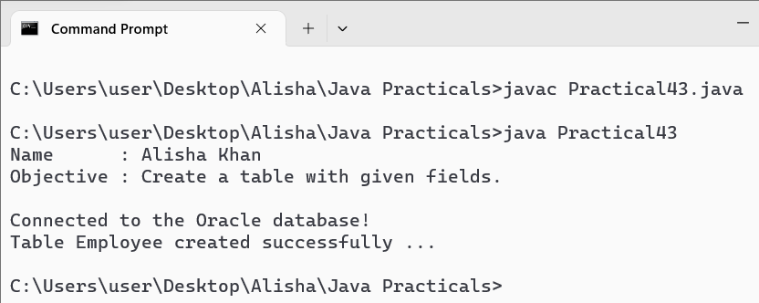

WAP to create a table and drop it.

Code :
import java.sql.Connection;
import java.sql.DriverManager;
import java.sql.SQLException;
import java.sql.Statement;

// CLASSPATH : C:\Users\Desktop\Alisha\Java Practicals\ojdbc11.jar

public class Practical44 {
public static void main(String[] args) {
System.out.println("Name : Alisha Khan");
System.out.println("Objective : Create and drop a table.\n");

try {
// Step 1 : Load the Oracle JDBC driver
Class.forName("oracle.jdbc.OracleDriver");

// Step 2 : Establish connection
Connection connect = DriverManager.getConnection("jdbc:oracle:thin:@localhost:1521:xe", "ALISHA_KHAN", "SYS1234");
System.out.println("Connected to the Oracle database!");

// Step 3 : Create a statement
Statement smt = connect.createStatement();

// Step 4 : Execute SQL query to create the table
smt.executeUpdate("CREATE TABLE Department (" +
"dept_id NUMBER PRIMARY KEY, " +
"dept_name VARCHAR(50), " +
"location VARCHAR(50))");
System.out.println("\nTable Department created successfully ...");

// Step 5 : Execute SQL query to drop the table
smt.executeUpdate("DROP TABLE Department");
System.out.println("\nTable Department dropped successfully ...");

// Step 6 : Close the connection
connect.close();

}

catch (ClassNotFoundException e) {
System.out.println("Oracle JDBC driver not found.");
e.printStackTrace();
} catch (SQLException e) {
System.out.println("Failed to connect to the Oracle database or create/drop the table!!");
e.printStackTrace();
}
}
}

Output :

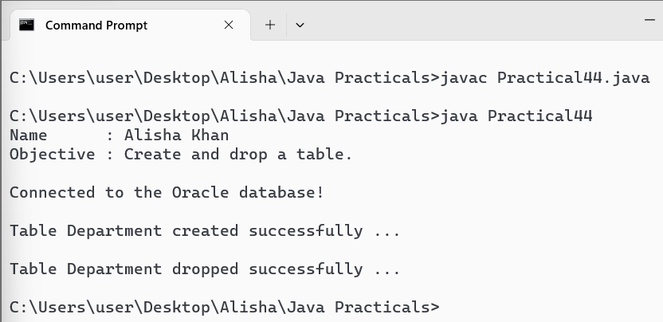

WAP to insert multiple rows in a table using prepared statement.
Code :
import java.sql.Connection;
import java.sql.DriverManager;
import java.sql.PreparedStatement;
import java.sql.SQLException;

public class Practical45 {
public static void main(String[] args) {
System.out.println("Name : Alisha Khan");
System.out.println("Objective : Create a table and insert multiple rows using PreparedStatement.\n");

Connection connect = null;
PreparedStatement pstmt = null;
try {
// Step 1 : Load the Oracle JDBC driver
Class.forName("oracle.jdbc.OracleDriver");

// Step 2 : Establish connection
connect = DriverManager.getConnection("jdbc:oracle:thin:@localhost:1521:xe", "ALISHA_KHAN", "SYS1234");
System.out.println("Connected to the Oracle database!");

// Step 3 : Create a statement to create the table
String createTableSQL = "CREATE TABLE Product (" +
"product_id NUMBER PRIMARY KEY, " +
"product_name VARCHAR(100), " +
"price FLOAT)";
pstmt = connect.prepareStatement(createTableSQL);
pstmt.executeUpdate();
System.out.println("\nTable Product created successfully ...");

// Step 4 : Create a prepared statement for inserting data
String insertSQL = "INSERT INTO Product (product_id, product_name, price) VALUES (?, ?, ?)";
pstmt = connect.prepareStatement(insertSQL);

// Step 5 : Set parameters and execute the prepared statement for multiple rows
pstmt.setInt(1, 1);
pstmt.setString(2, "Laptop");
pstmt.setFloat(3, 1200.0f);
pstmt.executeUpdate();

pstmt.setInt(1, 2);
pstmt.setString(2, "Smartphone");
pstmt.setFloat(3, 800.0f);
pstmt.executeUpdate();

pstmt.setInt(1, 3);
pstmt.setString(2, "Tablet");
pstmt.setFloat(3, 500.0f);
pstmt.executeUpdate();

System.out.println("\nInserted multiple rows into the Product table successfully ...");

} catch (ClassNotFoundException e) {
System.out.println("Oracle JDBC driver not found.");
e.printStackTrace();
} catch (SQLException e) {
System.out.println("Failed to connect to the Oracle database or create/insert the table!!");
e.printStackTrace();
} finally {
// Step 6 : Close the resources
try {
if (pstmt != null) pstmt.close();
if (connect != null) connect.close();
} catch (SQLException e) {
System.out.println("Failed to close the resources!");
e.printStackTrace();
}
}
}
}

Output :

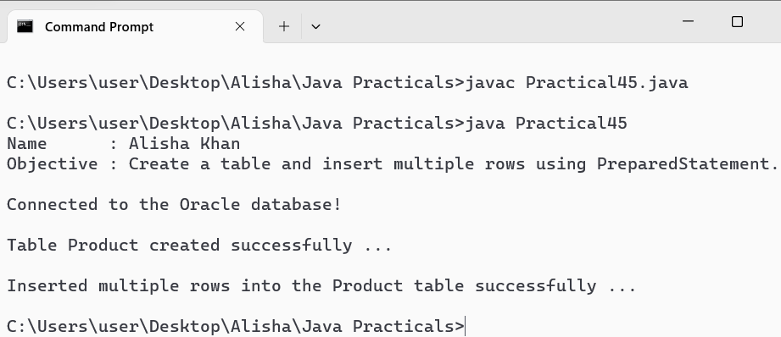

WAP to display contents of a table on the console.
Code :
import java.sql.Connection;
import java.sql.Statement;
import java.sql.DriverManager;
import java.sql.ResultSet;
import java.sql.SQLException;

public class Practical46 {
public static void main(String[] args) {
System.out.println("Name : Alisha Khan");
System.out.println("Objective : Display contents of the Product table.\n");

Connection connect = null;
Statement stmt = null;
ResultSet rs = null;

try {
// Step 1 : Establish connection
connect = DriverManager.getConnection("jdbc:oracle:thin:@localhost:1521:xe", "ALISHA_KHAN", "SYS1234");
System.out.println("Connected to the Oracle database!");

// Step 2 : Create a statement for SELECT query
stmt = connect.createStatement();

// Step 3 : Execute the query and get the result set
rs = stmt.executeQuery("SELECT * FROM Product");

// Step 4 : Iterate over the result set and display the contents
System.out.println("\nProduct Table Contents : \n");
System.out.printf("%-10s %-20s %-10s\n", "Product ID", "Product Name", "Price");
while (rs.next()) {
int productId = rs.getInt("product_id");
String productName = rs.getString("product_name");
float price = rs.getFloat("price");
System.out.printf("%-10d %-20s %-10.2f\n", productId, productName, price);
}

} catch (SQLException e) {
System.out.println("Failed to connect to the database or execute the query!!");
e.printStackTrace();
} finally {

// Step 5 : Close the resources
try {
if (rs != null) rs.close();
if (stmt != null) stmt.close();
if (connect != null) connect.close();
} catch (SQLException e) {
System.out.println("Failed to close the resources!");
e.printStackTrace();
}
}
}
}

Output :

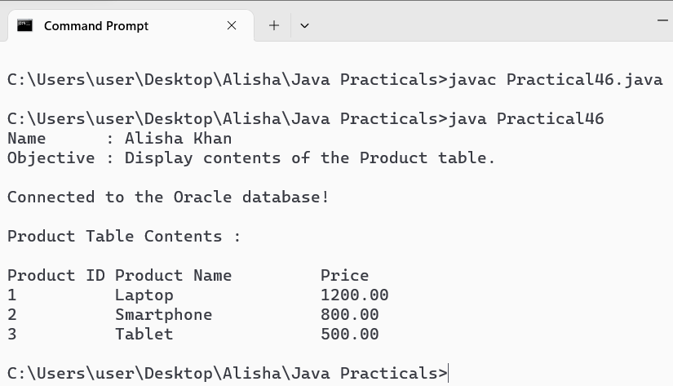

WAP to update rows using result set.
Code :
import java.sql.Connection;
import java.sql.DriverManager;
import java.sql.ResultSet;
import java.sql.SQLException;
import java.sql.Statement;

public class Practical47 {
public static void main(String[] args) {
System.out.println("Name : Alisha Khan");
System.out.println("Objective : Update rows of Product table using ResultSet and display the updated content.\n");

Connection connect = null;
Statement stmtUpdate = null;
Statement stmtSelect = null;
ResultSet rs = null;

try {
// Step 1 : Establish connection
connect = DriverManager.getConnection("jdbc:oracle:thin:@localhost:1521:xe", "ALISHA_KHAN", "SYS1234");
System.out.println("Connected to the Oracle database!");

// Step 2 : Create a statement for updating data
stmtUpdate = connect.createStatement();

// Step 3 : Update rows in the database using SQL UPDATE statement
stmtUpdate.executeUpdate("UPDATE Product SET price = price * 1.1");

// Step 4 : Create a statement for SELECT query
stmtSelect = connect.createStatement();

// Step 5 : Execute the SELECT query to display the updated contents
rs = stmtSelect.executeQuery("SELECT * FROM Product");

// Step 6 : Display the updated contents
System.out.println("\nProduct Table Contents (After Update):");
System.out.printf("%-10s %-20s %-10s\n", "Product ID", "Product Name", "Price");
while (rs.next()) {
int productId = rs.getInt("product_id");
String productName = rs.getString("product_name");

float price = rs.getFloat("price");
System.out.printf("%-10d %-20s %-10.2f\n", productId, productName, price);
}

} catch (SQLException e) {
System.out.println("Failed to connect to the database or execute the query!!");
e.printStackTrace();
} finally {
// Step 7 : Close the resources in the finally block
try {
if (rs != null) rs.close();
if (stmtUpdate != null) stmtUpdate.close();
if (stmtSelect != null) stmtSelect.close();
if (connect != null) connect.close();
} catch (SQLException e) {
System.out.println("Failed to close the resources!");
e.printStackTrace();
}
}
}
}

Output :

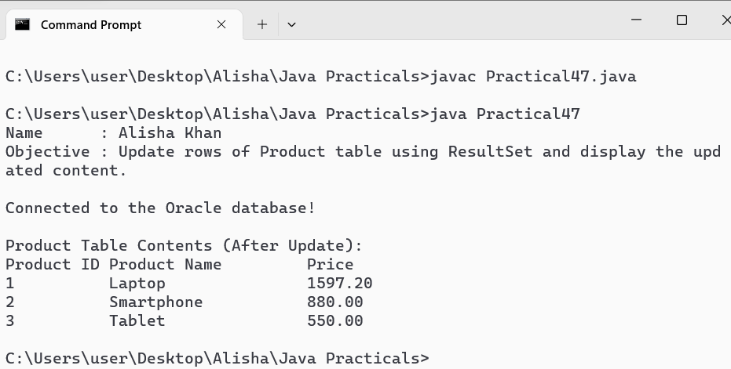

WAP to describe the functions of metadata objects.(resultset & database)
Code :
import java.sql.Connection;
import java.sql.DriverManager;
import java.sql.ResultSet;
import java.sql.ResultSetMetaData;
import java.sql.SQLException;
import java.sql.DatabaseMetaData;

public class Practical48 {
public static void main(String[] args) {
System.out.println("Name : Alisha Khan");
System.out.println("Objective : Describe the functions of metadata objects (ResultSet & Database).\n");
try {
Connection connection = DriverManager.getConnection("jdbc:oracle:thin:@localhost:1521:xe", "ALISHA_KHAN", "SYS1234");

// Demonstrating ResultSetMetaData
ResultSet resultSet = connection.createStatement().executeQuery("SELECT * FROM Product");
ResultSetMetaData resultSetMetaData = resultSet.getMetaData();
System.out.println("Number of Columns in Product Table: " + resultSetMetaData.getColumnCount());

// Demonstrating DatabaseMetaData
DatabaseMetaData databaseMetaData = connection.getMetaData();
System.out.println("Database Product Name : " + databaseMetaData.getDatabaseProductName());
System.out.println("Database Product Version : " + databaseMetaData.getDatabaseProductVersion());
System.out.println("Driver Name : " + databaseMetaData.getDriverName());
System.out.println("Driver Version : " + databaseMetaData.getDriverVersion());

connection.close();
} catch (SQLException e) {
e.printStackTrace();
}
}
}

Output :

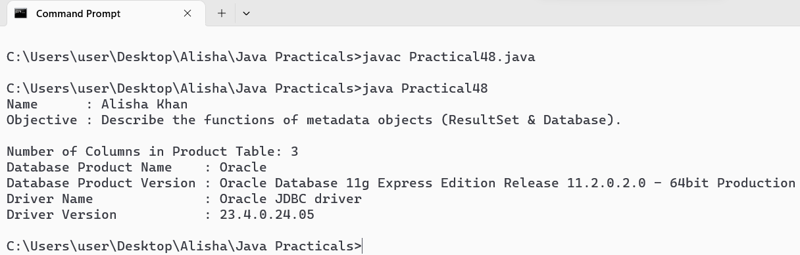

WAP to demonstrate the HashMap class .
Code :
import java.util.HashMap;
import java.util.Map;

public class Practical51 {
public static void main(String[] args) {
System.out.println("Name : Alisha Khan");
System.out.println("Objective : Demonstrate the HashMap class.\n");

HashMap<String, String> countryCapitals = new HashMap<>();

// Add key-value pairs to the HashMap
countryCapitals.put("USA", "Washington, D.C.");
countryCapitals.put("Canada", "Ottawa");
countryCapitals.put("Germany", "Berlin");
countryCapitals.put("Japan", "Tokyo");
countryCapitals.put("Australia", "Canberra");

// Print the HashMap
System.out.println("Initial HashMap: " + countryCapitals);

// Retrieve values based on keys
System.out.println("\nCapital of USA: " + countryCapitals.get("USA"));
System.out.println("Capital of Japan: " + countryCapitals.get("Japan"));

// Check if the HashMap contains specific keys or values
System.out.println("\nDoes the HashMap contain 'Germany'? " + countryCapitals.containsKey("Germany"));
System.out.println("Does the HashMap contain the capital 'Ottawa'? " + countryCapitals.containsValue("Ottawa"));

// Remove an entry from the HashMap
countryCapitals.remove("Australia");
System.out.println("\nHashMap after removing 'Australia': " + countryCapitals);

// Iterate over the HashMap
System.out.println("\nIterating over HashMap:");
for (Map.Entry<String, String> entry : countryCapitals.entrySet()) {
System.out.println("Country: " + entry.getKey() + ", Capital: " + entry.getValue());
}

// Get the size of the HashMap
System.out.println("\nSize of the HashMap: " + countryCapitals.size());

// Clear all entries from the HashMap
countryCapitals.clear();
System.out.println("\nHashMap after clear: " + countryCapitals);
}
}

Output :

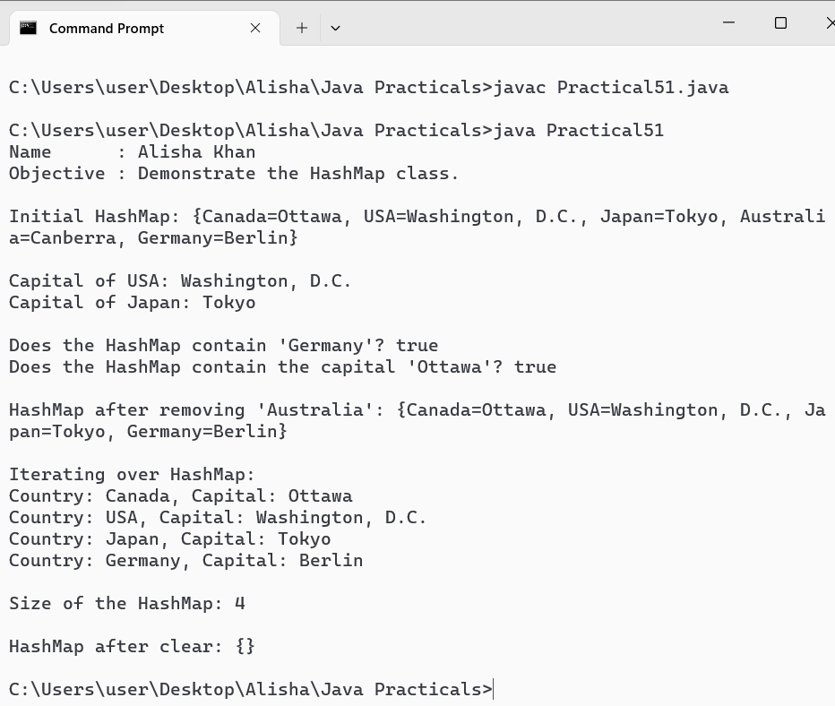

WAP to demonstrate the vector class.
Code :
import java.util.Vector;

public class Practical52 {
public static void main(String[] args) {
System.out.println("Name : Alisha Khan");
System.out.println("Objective : Demonstrate the vector class.\n");

// Create a Vector of String type
Vector<String> books = new Vector<>();

// Add elements to the Vector
books.add("The Catcher in the Rye");
books.add("To Kill a Mockingbird");
books.add("1984");
books.add("Pride and Prejudice");
books.add("The Great Gatsby");

// Print the Vector
System.out.println("Initial Vector: " + books);

// Access elements by index
System.out.println("\nElement at index 0: " + books.get(0));
System.out.println("Element at index 2: " + books.get(2));

// Check if the Vector contains a specific element
System.out.println("Does the Vector contain '1984'? : " + books.contains("1984"));
System.out.println("Does the Vector contain 'Moby Dick'? : " + books.contains("Moby Dick"));

// Remove an element from the Vector
books.remove("Pride and Prejudice");
System.out.println("\nVector after removing 'Pride and Prejudice': " + books);

// Iterate over the Vector
System.out.println("\nIterating over Vector:");
int count = 1;
for (String book : books) {
System.out.println(count + "." +book);
count++;
}

// Get the size of the Vector
System.out.println("\nSize of the Vector: " + books.size());

// Clear all elements from the Vector
books.clear();
System.out.println("\nVector after clear: " + books);
}
}

Output :

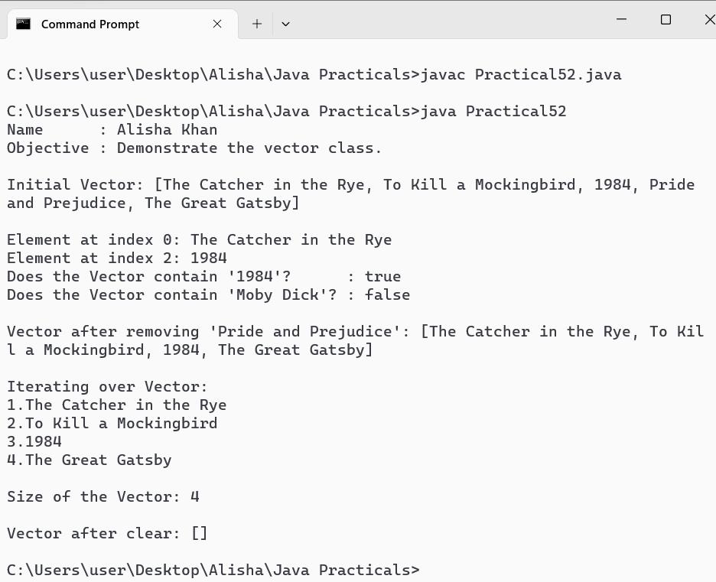

WAP to demonstrate the LinkedList class.
Code :
import java.util.LinkedList;
import java.util.Iterator;

public class Practical53 {
public static void main(String[] args) {
System.out.println("Name : Alisha Khan");
System.out.println("Objective : Demonstrate LinkedList class.\n");

// Create a LinkedList
LinkedList<String> fruits = new LinkedList<>();

// Add elements to the LinkedList
fruits.add("Apple");
fruits.add("Banana");
fruits.add("Cherry");
fruits.add("Date");

// Display the LinkedList
System.out.println("LinkedList: " + fruits);

// Add an element at the first position
fruits.addFirst("Elderberry");
System.out.println("\nAfter adding Elderberry at the first position : " + fruits);

// Add an element at the last position
fruits.addLast("Fig");
System.out.println("After adding Fig at the last position : " + fruits);

// Get the first element
String firstElement = fruits.getFirst();
System.out.println("\nFirst element : " + firstElement);

// Get the last element
String lastElement = fruits.getLast();
System.out.println("Last element : " + lastElement);

// Remove the first element
fruits.removeFirst();
System.out.println("\nAfter removing the first element : " + fruits);

// Remove the last element
fruits.removeLast();
System.out.println("After removing the last element : " + fruits);

// Iterate through the LinkedList
System.out.print("\nIterating through the LinkedList: ");
Iterator<String> iterator = fruits.iterator();
while (iterator.hasNext()) {
System.out.print(iterator.next() + " ");
}
System.out.println();

// Check if the LinkedList contains a specific element
boolean containsCherry = fruits.contains("Cherry");
System.out.println("\nLinkedList contains Cherry : " + containsCherry);

// Clear the LinkedList
fruits.clear();
System.out.println("\nAfter clearing the LinkedList: " + fruits);
}
}

Output :

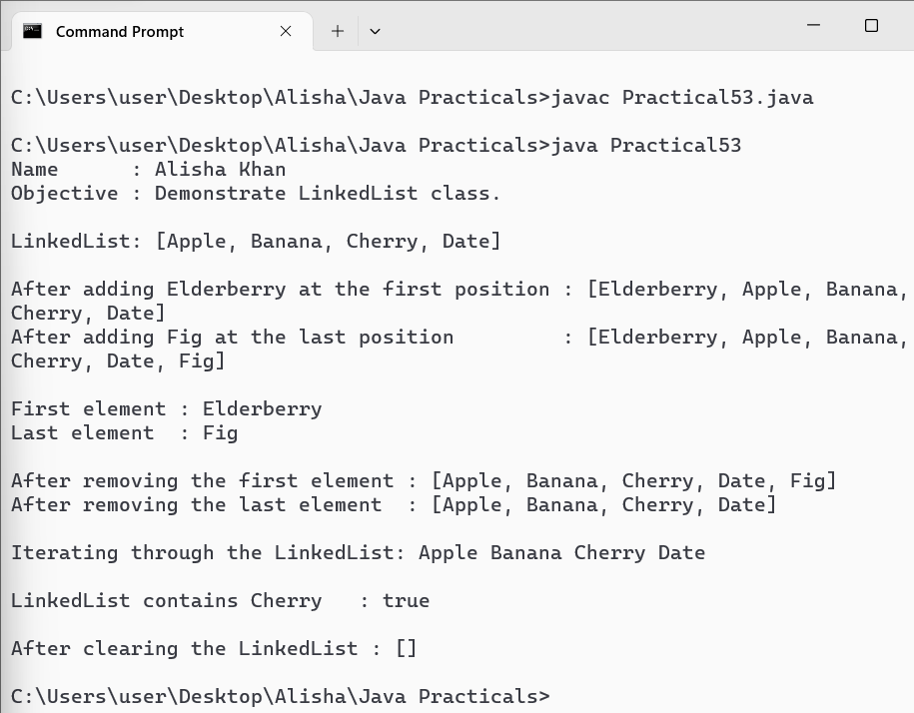

WAP to demonstrate the JtextField class.
Code :
import javax.swing.*;
import java.awt.*;
import java.awt.event.ActionEvent;
import java.awt.event.ActionListener;

public class Practical54 {
public static void main(String[] args) {
System.out.println("Name : Alisha Khan");
System.out.println("Objective : Demonstrate JtextField class.\n");

JFrame frame = new JFrame("JTextField Demo");
frame.setSize(300, 200);
frame.setDefaultCloseOperation(JFrame.EXIT_ON_CLOSE);

JPanel panel = new JPanel();
panel.setLayout(new FlowLayout());

JLabel enterTextLabel = new JLabel("Enter text: "); // Label before the text field
panel.add(enterTextLabel);

JTextField textField = new JTextField(20); // 20 columns wide
panel.add(textField);

JButton button = new JButton("Submit");
panel.add(button);

// ActionListener for the button
button.addActionListener(new ActionListener() {
@Override
public void actionPerformed(ActionEvent e) {
String text = textField.getText(); // Get text from the text field
System.out.println("Text entered: " + text); // Display text in console
}
});

frame.add(panel);
frame.setVisible(true);
}
}

Output :

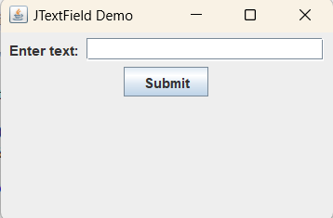

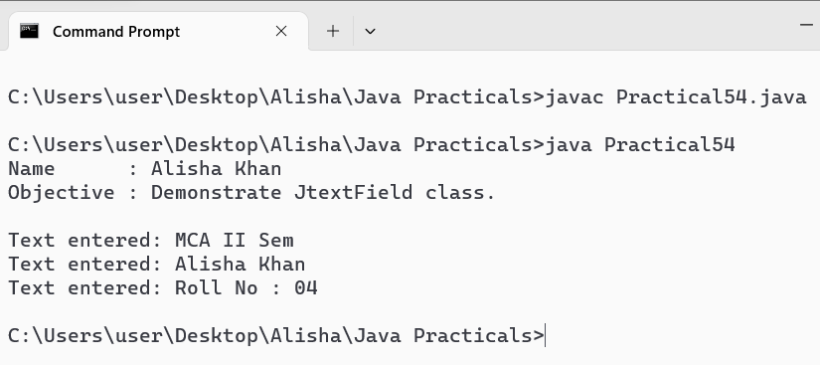

WAP to demonstrate the JButton class.
Code :
import javax.swing.*;
import java.awt.*;
import java.awt.event.ActionEvent;
import java.awt.event.ActionListener;

public class Practical55 {
public static void main(String[] args) {
System.out.println("Name : Alisha Khan");
System.out.println("Objective : Demonstrate JButton class.\n");

JFrame frame = new JFrame("JButton Demo");
frame.setSize(300, 200);
frame.setDefaultCloseOperation(JFrame.EXIT_ON_CLOSE);

JPanel panel = new JPanel();
panel.setLayout(new FlowLayout());

JButton button = new JButton("Click Me!"); // Creating JButton with label "Click Me!"
panel.add(button); // Adding button to the panel

// ActionListener for the button
button.addActionListener(new ActionListener() {
@Override
public void actionPerformed(ActionEvent e) {
// Display a message dialog box when button is clicked
JOptionPane.showMessageDialog(frame, "Button Clicked!");
}
});

frame.add(panel);
frame.setVisible(true);
}
}

Output:

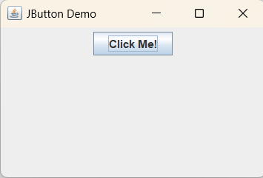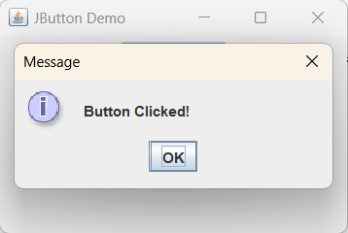

WAP to demonstrate the JToggleButton class.
Code :
import javax.swing.*;
import java.awt.*;
import java.awt.event.ActionEvent;
import java.awt.event.ActionListener;

public class Practical56 {
public static void main(String[] args) {
JFrame frame = new JFrame("JToggleButton Demo");
frame.setSize(400, 300);
frame.setDefaultCloseOperation(JFrame.EXIT_ON_CLOSE);

JPanel panel = new JPanel();
panel.setLayout(new FlowLayout());

JToggleButton toggleButton = new JToggleButton("Toggle Me!"); // Creating JToggleButton with label "Toggle Me!"
panel.add(toggleButton); // Adding toggle button to the panel

// ActionListener for the toggle button
toggleButton.addActionListener(new ActionListener() {
@Override
public void actionPerformed(ActionEvent e) {
// Check if the toggle button is selected
if (toggleButton.isSelected()) {
JOptionPane.showMessageDialog(frame, "Toggle button is selected!"); // Display message if selected
} else {
JOptionPane.showMessageDialog(frame, "Toggle button is deselected!"); // Display message if deselected
}
}
});

frame.add(panel);
frame.setVisible(true);
}
}

Output :

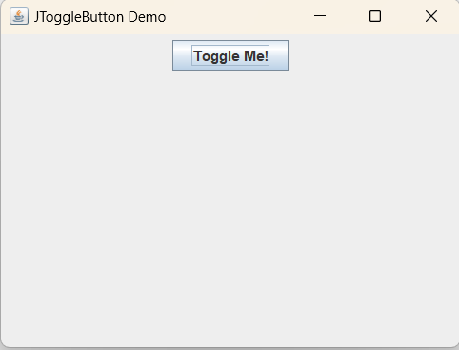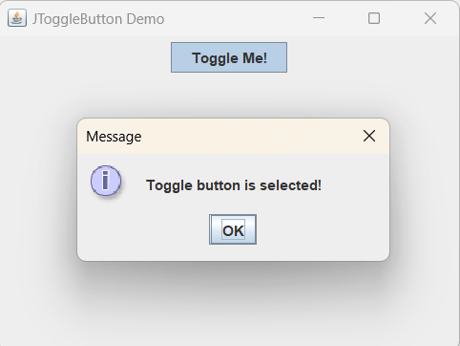

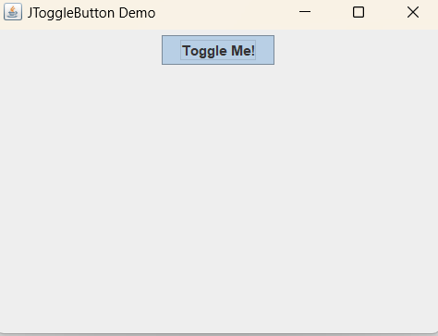

WAP to demonstrate the JCheckbox class.
Code :
import javax.swing.*;
import java.awt.*;
import java.awt.event.ActionEvent;
import java.awt.event.ActionListener;

public class Practical57 {
public static void main(String[] args) {
System.out.println("Name : Alisha Khan");
System.out.println("Objective : Demonstrate JCheckBox class.\n");

System.out.println("List of completed Tasks : ");

JFrame frame = new JFrame("Programming Tasks To-Do List");
frame.setSize(400, 300);
frame.setDefaultCloseOperation(JFrame.EXIT_ON_CLOSE);

JPanel panel = new JPanel();
panel.setLayout(new GridLayout(0, 1)); // Vertical layout for checkboxes

// Array of programming tasks
String[] tasks = {
"Finish coding assignment",
"Fix bugs in the project",
"Implement new feature",
"Write unit tests",
"Refactor code for better readability"
};

// Create checkboxes for each task
for (String task : tasks) {
JCheckBox checkBox = new JCheckBox(task);
checkBox.addActionListener(new ActionListener() {
@Override
public void actionPerformed(ActionEvent e) {
if (checkBox.isSelected()) {
System.out.println("Task completed: " + task);
}
}
});
panel.add(checkBox);
}

frame.add(panel);
frame.setVisible(true);
}
}

Output :

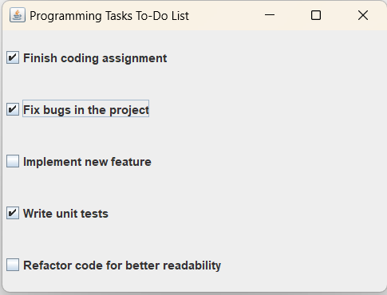

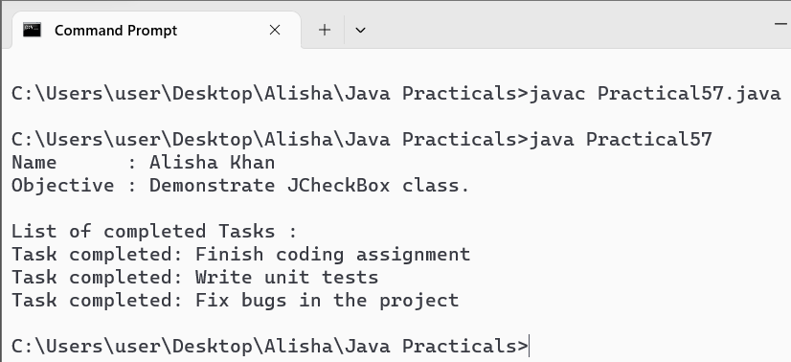

WAP to demonstrate the JRadioButtun class.
Code :
import javax.swing.*;
import java.awt.*;
import java.awt.event.ActionEvent;
import java.awt.event.ActionListener;

public class Practical58 {
public static void main(String[] args) {
JFrame frame = new JFrame("JRadioButton Demo");
frame.setSize(400, 300);
frame.setDefaultCloseOperation(JFrame.EXIT_ON_CLOSE);

JPanel panel = new JPanel();
panel.setLayout(new GridLayout(0, 1)); // Vertical layout for radio buttons

// Create a button group for radio buttons
ButtonGroup buttonGroup = new ButtonGroup();

// Array of options
String[] options = {
"Option 1: Complete coding assignment",
"Option 2: Fix bugs in the project",
"Option 3: Implement new feature"
};

// Create radio buttons for each option
for (String option : options) {
JRadioButton radioButton = new JRadioButton(option);
buttonGroup.add(radioButton); // Add radio button to button group
panel.add(radioButton); // Add radio button to panel

// Add ActionListener to radio button
radioButton.addActionListener(new ActionListener() {
@Override
public void actionPerformed(ActionEvent e) {
// Display the selected option in a message dialog
JOptionPane.showMessageDialog(frame, "Selected option: " + option);
}
});
}

frame.add(panel);
frame.setVisible(true);
}
}

Output :

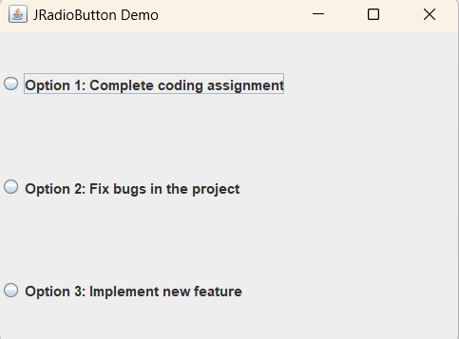

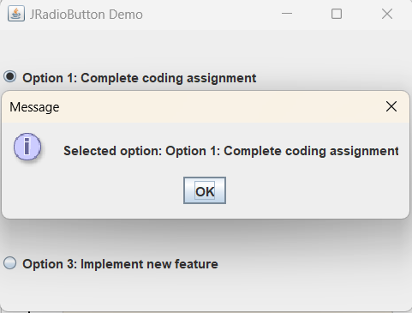

WAP to demonstrate the JComboBox class.
Code :
import javax.swing.*;
import java.awt.*;
import java.awt.event.ActionEvent;
import java.awt.event.ActionListener;

public class Practical59 {
public static void main(String[] args) {
JFrame frame = new JFrame("JComboBox Demo");
frame.setSize(400, 400); // Increased size to 400x200 pixels
frame.setDefaultCloseOperation(JFrame.EXIT_ON_CLOSE);

JPanel panel = new JPanel();
panel.setLayout(new FlowLayout());

// Array of programming languages
String[] languages = {"Java", "Python", "C++", "JavaScript", "Swift"};

// Create a JComboBox with the array of languages
JComboBox<String> comboBox = new JComboBox<>(languages);
panel.add(comboBox);

// ActionListener for the combo box
comboBox.addActionListener(new ActionListener() {
@Override
public void actionPerformed(ActionEvent e) {
// Get the selected item from the combo box
String selectedLanguage = (String) comboBox.getSelectedItem();
// Display a message dialog with the selected language
JOptionPane.showMessageDialog(frame, "Selected language: " + selectedLanguage);
}
});

frame.add(panel);
frame.setVisible(true);
}
}

Output :

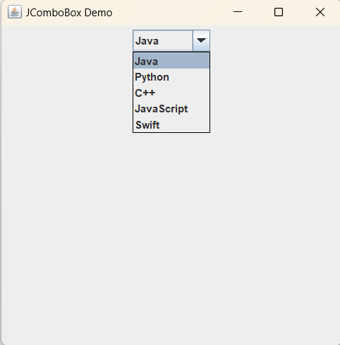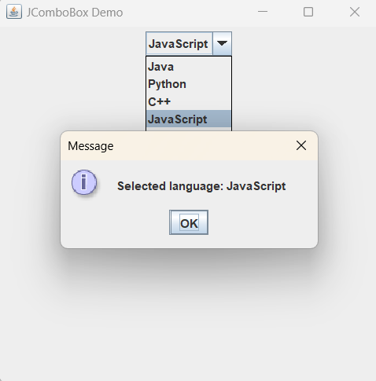

WAP to demonstrate the Jlist class.
Code :
import javax.swing.*;
import java.awt.*;
import java.awt.event.ActionEvent;
import java.awt.event.ActionListener;

public class Practical60 {
public static void main(String[] args) {
JFrame frame = new JFrame("JList Demo");
frame.setSize(400, 400);
frame.setDefaultCloseOperation(JFrame.EXIT_ON_CLOSE);

JPanel panel = new JPanel();
panel.setLayout(new FlowLayout());

// Array of programming languages
String[] languages = {"Java", "Python", "C++", "JavaScript", "Swift"};

// Create a JList with the array of languages
JList<String> languageList = new JList<>(languages);
panel.add(new JScrollPane(languageList)); // Add JList to JScrollPane and then to panel

// ListSelectionListener for the list
languageList.addListSelectionListener(e -> {
// Get the selected language from the list
String selectedLanguage = languageList.getSelectedValue();
// Display a message dialog with the selected language
JOptionPane.showMessageDialog(frame, "Selected language: " + selectedLanguage);
});

frame.add(panel);
frame.setVisible(true);
}
}

Output :

